JJC Li-ion Battery Pack
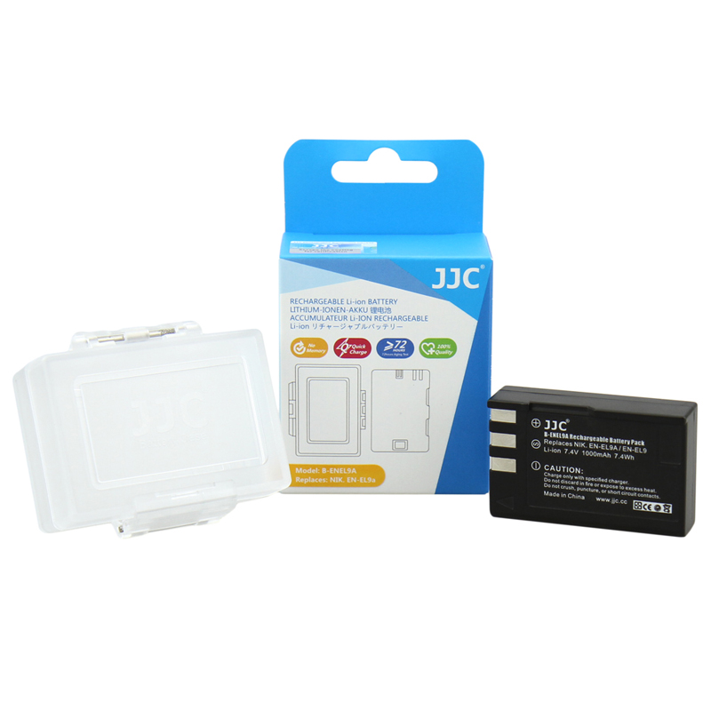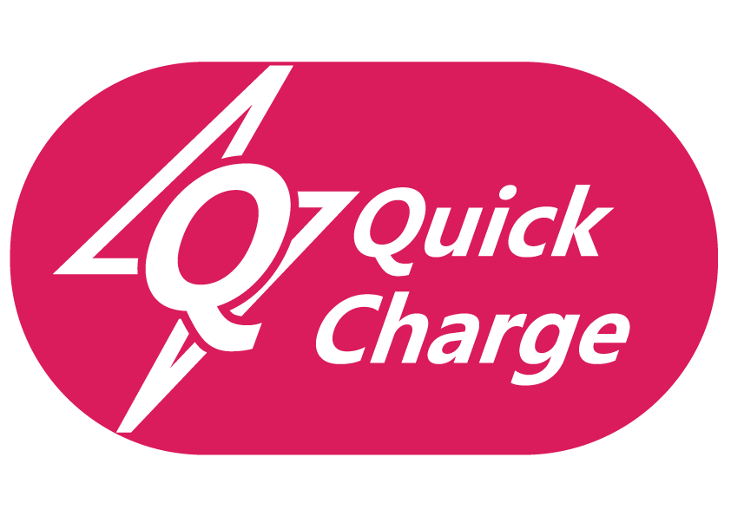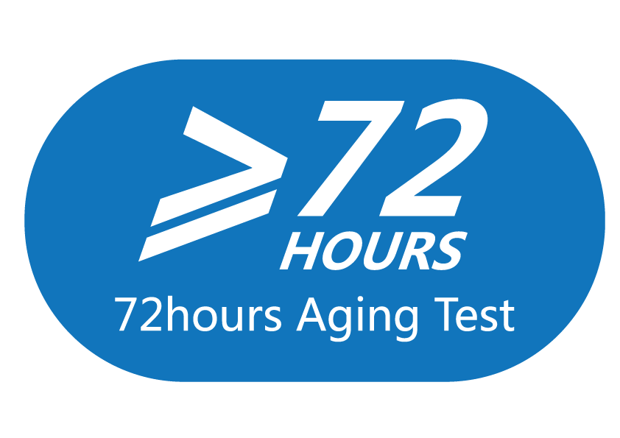
JJC Li-ion Battery Pack functions the same as the original battery pack it replaces. The battery fits and works perfectly with the applicable cameras. The li-ion battery from JJC is manufactured by high quality battery core, has the advantages of sufficient electricity, long duration, long life span. For every battery, we use strict quality control technology and 72hours aging test to make sure every battery is safe and reliable. Li-ion chemistry allows you to charge your battery as much or as little as need without any memory effect. Each battery comes with a water-resistant battery case to allow you store the battery when not in use. In this way, the contacts of the battery will be away from dust and moisture, thus prolongs the service life.

Model | Voltage | Capacity | Replaces | Compatible with
B-ENEL9A | 7.4V | 1000mAh | Nikon EN-EL9  Nikon EN-EL9A | Nikon D3000 D40 D40x  D5000 D60
B-LPE6 | 7.4V | 1750mAh | Canon LP-E6 | Canon EOS 5D Mark II  5D Mark III 60D 60Da  Canon EOS 70D 6D 7D
B-BP511A | 7.4V | 1400mAh | Canon BP-511  Canon BP-511A  Canon BP-512 | CANON EOS 10, EOS 10D, EOS 20D, EOS 300D, EOS 30D, EOS 40D, CANON EOS 50D, EOS 5D, EOS D30, EOS D60, EOS Digital Rebel, EOS KISS, CANON IXY DVM, PowerShot G1, G2, G3, G5, G6, Pro 1, Pro 90
B-ENEL10 | 3.7V | 700mAh | NIKON EN-EL10  FUJIFILM NP-45  OLYMPUS Li-40B  OLYMPUS Li-42B  CASIO NP-80  KODAK KILC-7006 PENTAX D-Li63  PENTAX D-Li108 | Nikon Coolpix S50C, 520B, S200, S210, S220, S230, S3000, S4000, S500  Nikon Coolpix S510, S520, S5100, S570, S60, S6000, S700, S80
B-ENEL3E | 7.4V | 1600mAh | Nikon EN-EL3e | Nikon D100, D200, D300, D300s, D50, D70, D700, D80, D80, D90
B-ENEL14 | 7.4V | 1050mAh | Nikon EN-EL14 | Nikon D3100, D3200, D5100, D5200, D5300,D3300  Nikon COOLPIX P7000, P7100, P7700, P7800
B-ENEL19 | 3.7V | 700mAh | Nikon EN-EL19 | Nikon COOLPIX S6500, S5200, S6400, S4300, S3300, S4100, S3100
B-ENEL12 | 3.7V | 900mAh | Nikon EN-EL12 | NIKON COOLPIX P330, AW110, S31, S9500, S800C, S9300, S6300, P310, AW100  NIKON COOLPIX S100, S1200pj, S6200, S8200, P300, S9100, S6100, S8100,S1100pj,  NIKON COOLPIX S6000, S8000, S640, S70, S630, S620, S710, S610c, S610
B-NPBX1 | 3.6V | 1240mAh | Sony NP-BX1 | Cyber-shot HX300 HX50V RX1 RX100 RX100II RX1R WX300  Compact POV action cam HDR-AS10  Action Cam with Wi-Fi HDR-AS15  Action Cam Golf Training Pack HDR-AS15 GOLF

Model | Voltage | Capacity | Replaces | Compatible with
B-LPE5 | 7.4V | 1080mAh | Canon LP-E5 | Canon EOS 1000D 450D 500D  Canon EOS Rebel SX, Rebel T1i, Rebel XS, Rebel XSi
B-LPE8 | 7.4V | 1120mAh | Canon LP-E8 | Canon EOS 550D 600D 650D  Canon EOS Rebel T2i T3i T4i T5i
B-NPBN1 | 3.6V | 630mAh | Sony NP-BN1 | SONY DSC-T110, T99, TF1, TX10, TX100, TX20, TX200, TX30, TX5, TX55, TX66  SONY DSC-TX7, TX9, W310, W320, W330, W350, W360, W370, W380, W390  SONY DSC-W510, W520, W530, W560, W570, W610, W620, W650, W690, W710  SONY DSC-W730, WX150, WX5, WX50, WX570, WX70, WX80, WX9
B-NPFW50 | 7.2V | 1080mAh | Sony NP-FW50 | Sony Alpha A560, A580, SLT-A33, SLT-A35, SLT-A37, SLT-A55, SLT-A58  Sony NEX-3, NEX-3N, NEX-5, NEX-5N, NEX-5R, NEX-6, NEX-7, NEX-C3, NEX-F3
B-NPBD1 | 3.6V | 680mAh | Sony NP-BD1  Sony NP-FD1 | Sony DSC-G1, DSC-G3, DSC-H50, DSC-T2, DSC-T200, DSC-T2000, DSC-T300  Sony DSC-T500, DSC-T70, DSC-T90, DSC-T900, DSC-TX1
B-NPBG1 | 3.6V | 945mAh | Sony NP-BG1  Sony NP-FG1 | Sony DSC-H10, H20, H3, H50, H55, H7, H70, H9, H90, HX10, HX20, HX30  Sony DSC-HX5, HX7, HX9, N1, N2, T100, T20, T9, W100, W110, W120, W130  Sony DSC-W150, W170, W200, W220, W230, W290, W30, W300, W35, W50  Sony DSC-W55, W70, W80, W90, WX1, WX10, HDR-GW77
B-NP95 | 3.6V | 1800mAh | FUJIFILM NP-95 | FUJIFILM X100/X100S
B-ENEL15 | 7V | 1900mAh | Nikon EN-EL15 | Nikon D800E D610 D600 D7100 D7000 D800 1 V1
B-BLS5 | 7.2V | 1250mAh | Olympus BLS-5 | E-P3 E-PL3 E-PL5 E-PM1 E-PM2 E-M10 STYLUS 1 E-PL2 E-PL1
B-NPW126 | 7.2V | 1260mAh | FUJIFILM NP-W126 | FUJIFILM X-Pro1/X-T1/X-E2/ X-E1/X-M1/ X-A1  FinePix HS50EXR/HS30EXR / HS33EXR
WWW.JJC.CC

