JJC LH-RBF49 Lens Hood
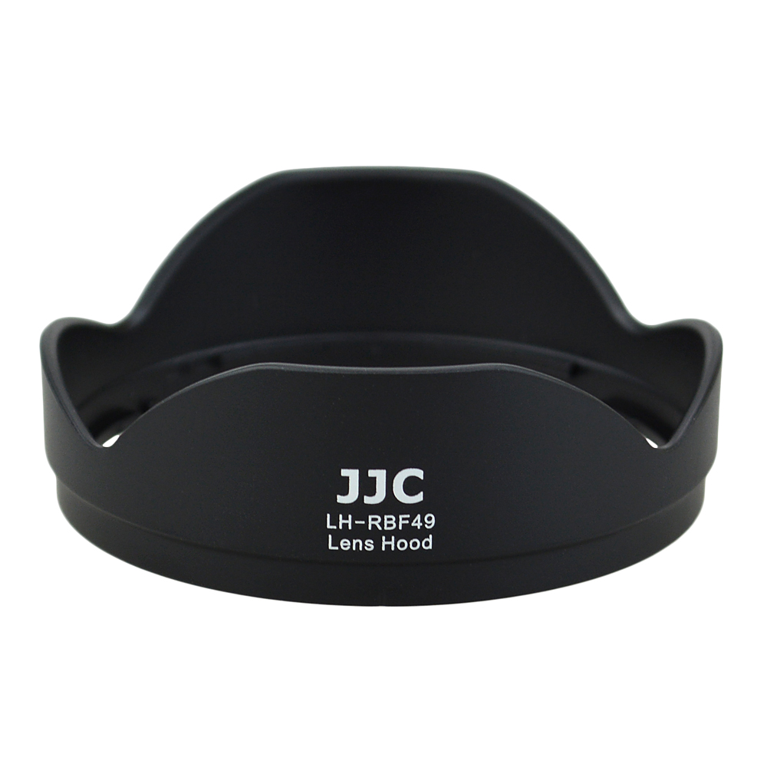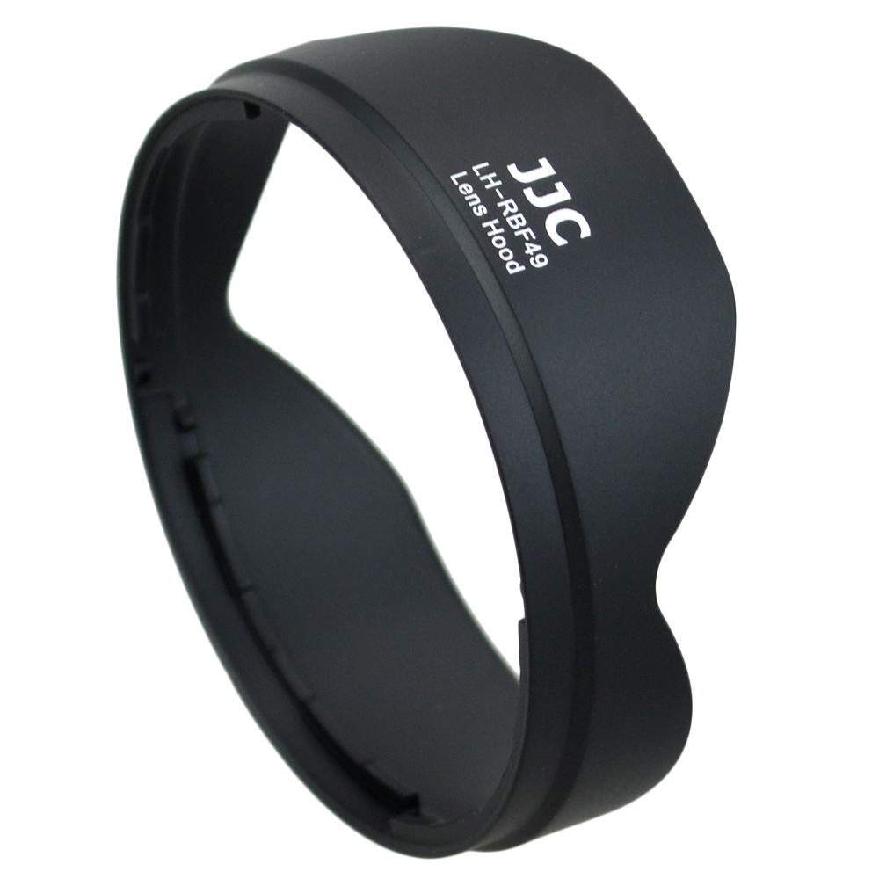
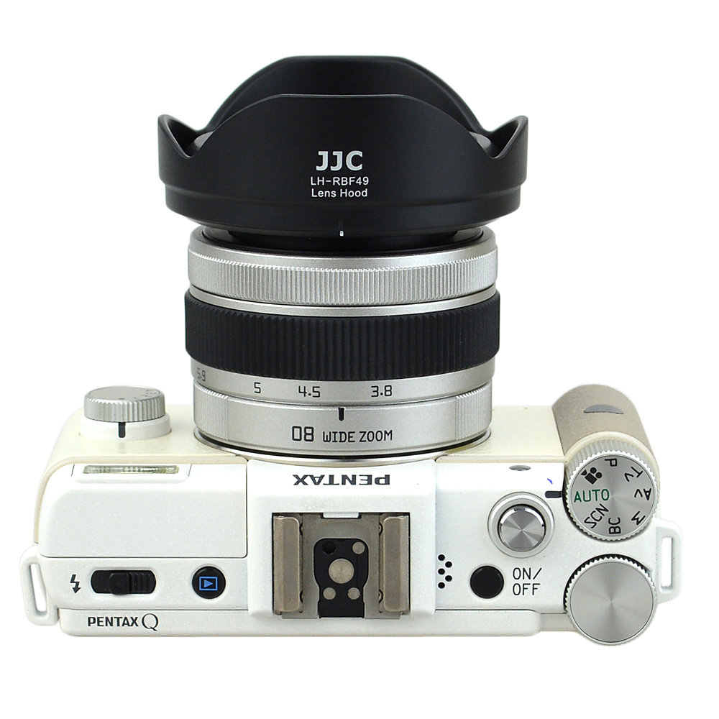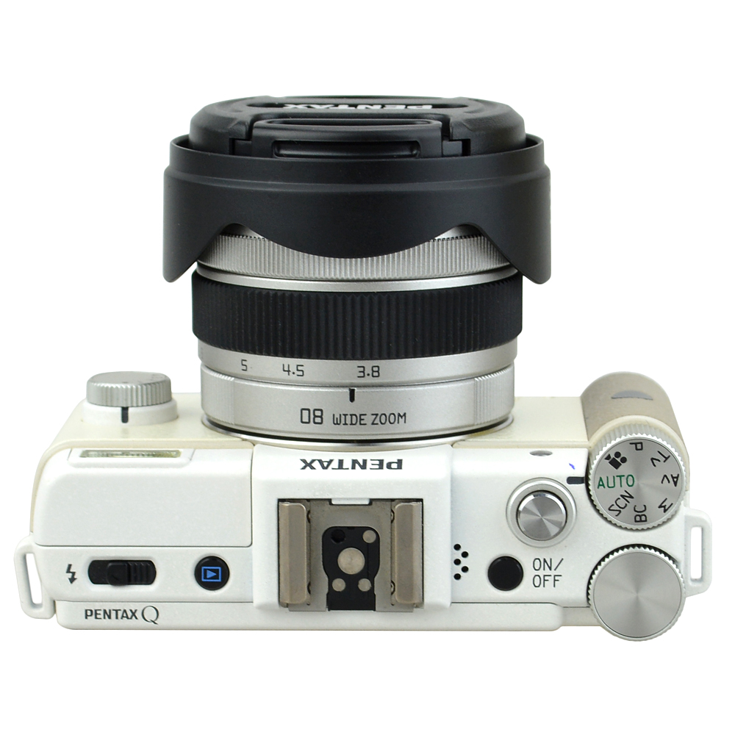
JJC LH-RBF49 Lens hood is designed for Pentax 08 Wide Zoom 3.8mm-5.9mm F3.7-4 Lens. Lens hoods are primarily designed to prevent unwanted stray light from entering the lens by extending and shading the end of the lens. JJC LH-RBF49 Lens hood features a non-glare matte finish on the interior surface to further prevent or limit lens flare. In addition, since the end of the lens is extended, you also get the added benefit of some extra protection from accidental impact. This flower shape lens hood also takes the final image's shape and aspect ratio into account. It allows the lens hood to block stray light with the higher portions of the lens hood, while allowing more light into the corners of the image through the lowered portions of the hood. This hood is also reversible to stay on lens when not in use. Now the original Pentax lens cap can be attached to the lens normally. JJC LH-RBF49 lens hood replaces Pentax PH-RBF49 lens hood.

Product highlights
- Prevent unwanted stray light from entering the lens
- Non-glare matte finish on the interior further preventing lens flare
- Extra protection from accidental impact
- Reversible to stay on lens
- Compatible with the original Pentax lens cap

Compatible with
Pentax 08 Wide Zoom 3.8mm-5.9mm F3.7-4 Lens

WWW.JJC.CC

