JJC LH-37EPII Metal Lens Hood
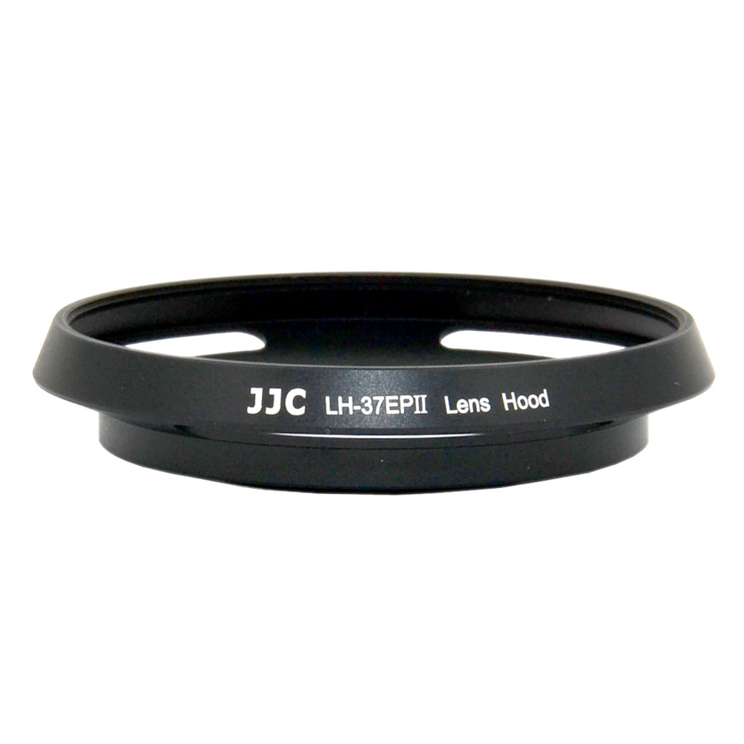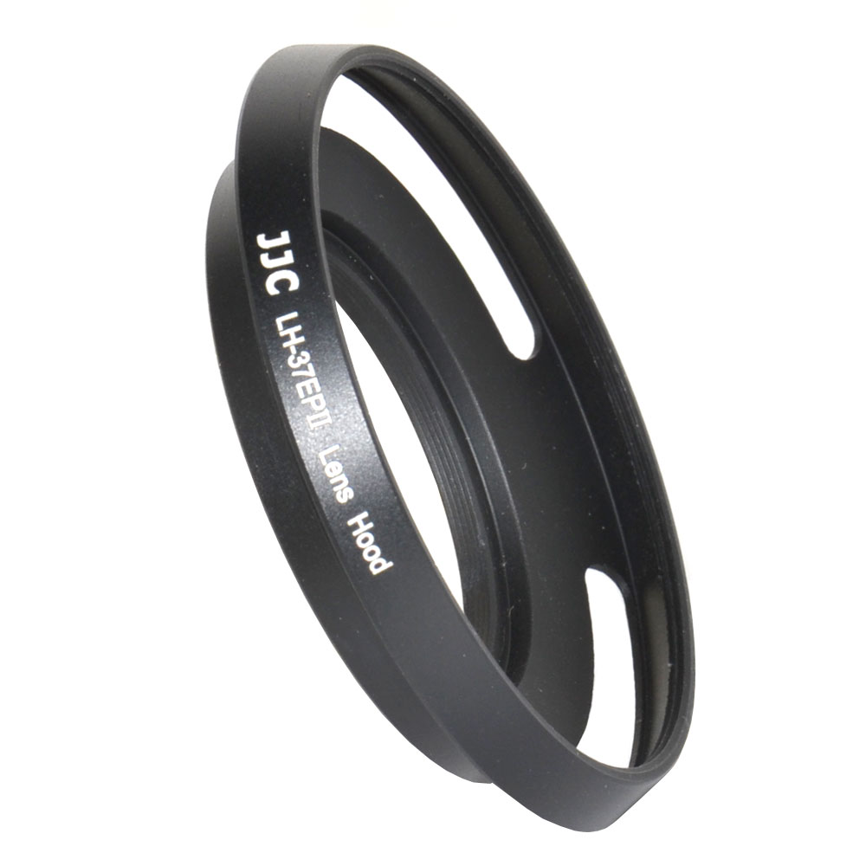
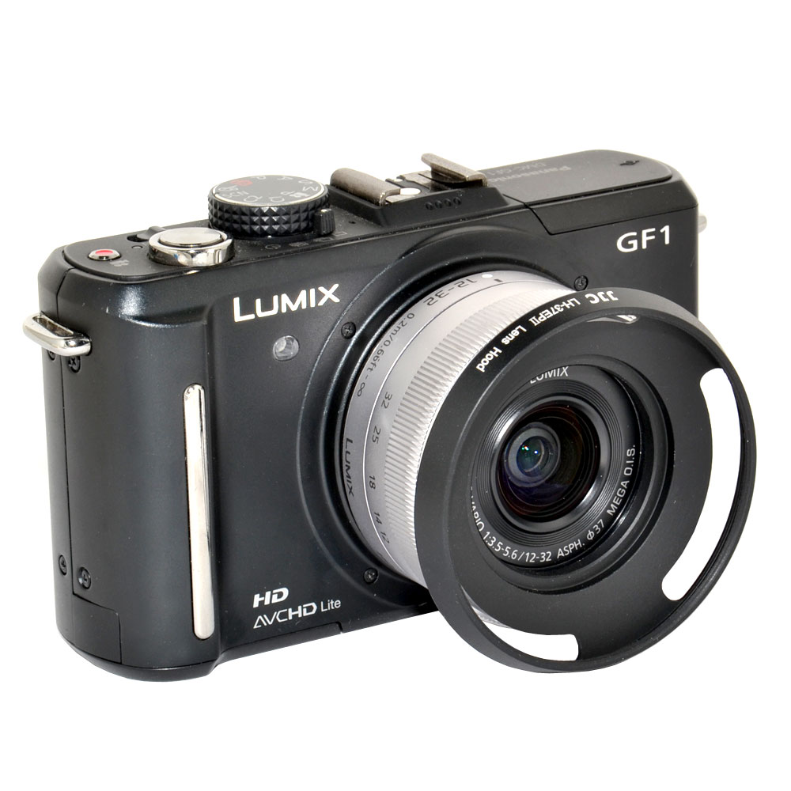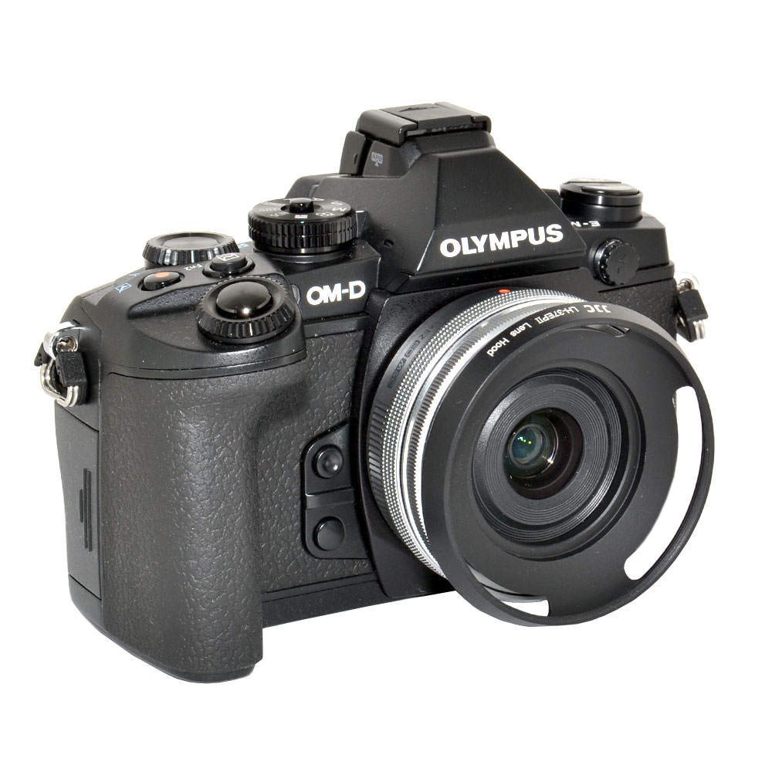
JJC LH-37EPII Metal Lens hood is designed to fit two lens: Panasonic Lumix G Vario 12-32mm f/3.5-5.6 ASPH. Lens and Olympus M.Zuiko Digital ED 14-42mm f/3.5-5.6 EZ Lens. The hood adopts a screw-on design and fits the above two lens well. It can even screw onto the filter that you already installed to the lens, at the same time the front of the hood provides you an extra 58mm filter mount thread. This hood will provide you many benefits: it shades the lens from stray light, improving your contrast and image quality; in inclement weather, it can assist in keeping moisture or wind-blown debris off the lens; and it protects the front barrel from the inevitable impacts against walls, door frames, and other real-life obstacles. JJC LH-37EPII will not cause vignetting.
Highlights
- Fine finished metal lens hood and fits well with the lens
- Blocks stray light from entering the lens
- Extra protection from accidental impact
- No vignetting will be caused
- Allows a JJC LC-37 lens cap on when hood is not being used
- Permits you use a filter and provides an extra 58mm filter mount thread

Compatible with
Panasonic Lumix G Vario 12-32mm f/3.5-5.6 ASPH. Lens
Olympus M.Zuiko Digital ED 14-42mm f/3.5-5.6 EZ Lens
WWW.JJC.CC

