JJC MC-SDMSD12 Memory Card Case
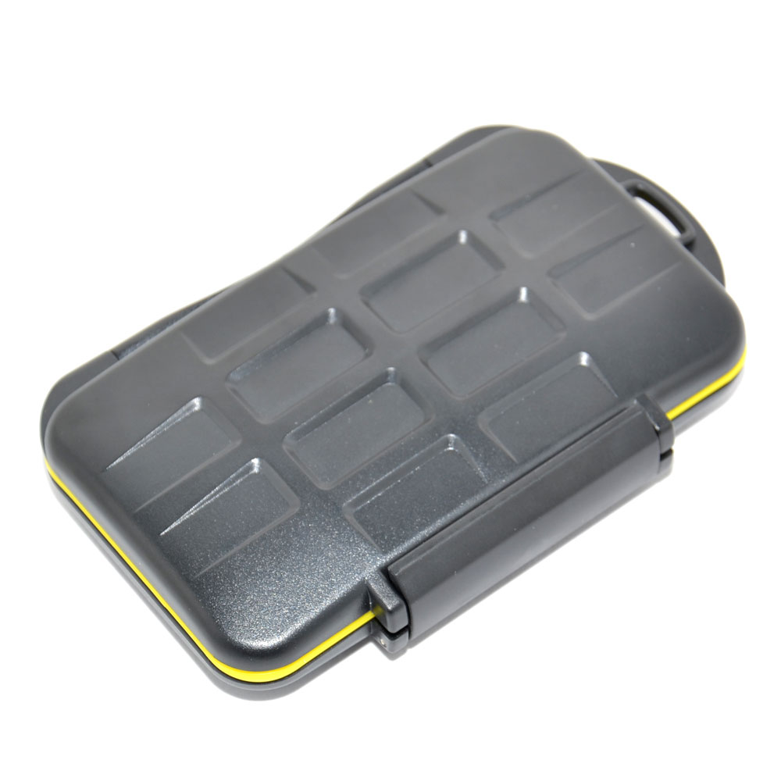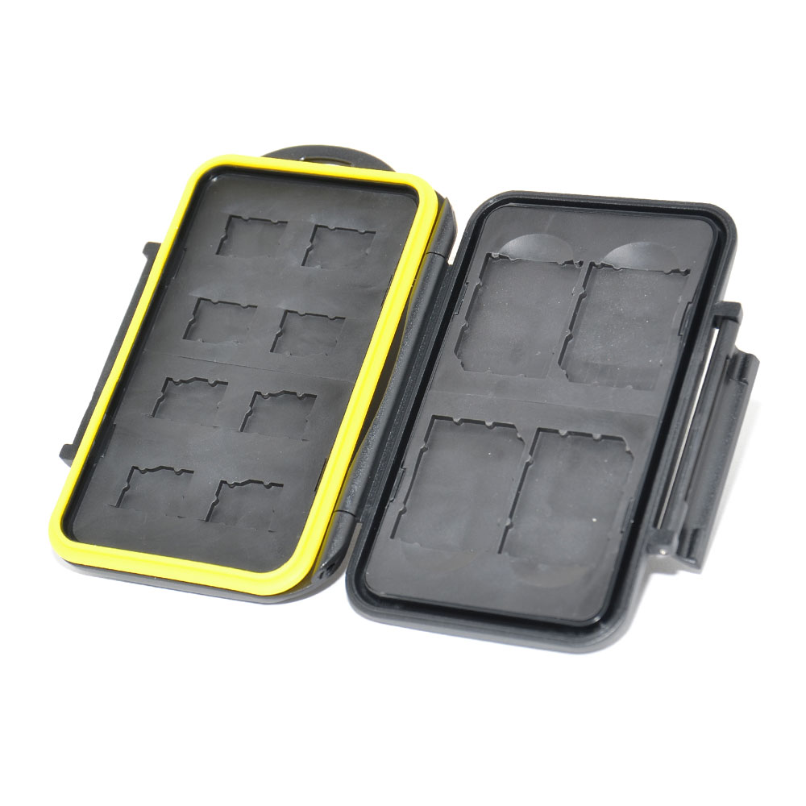
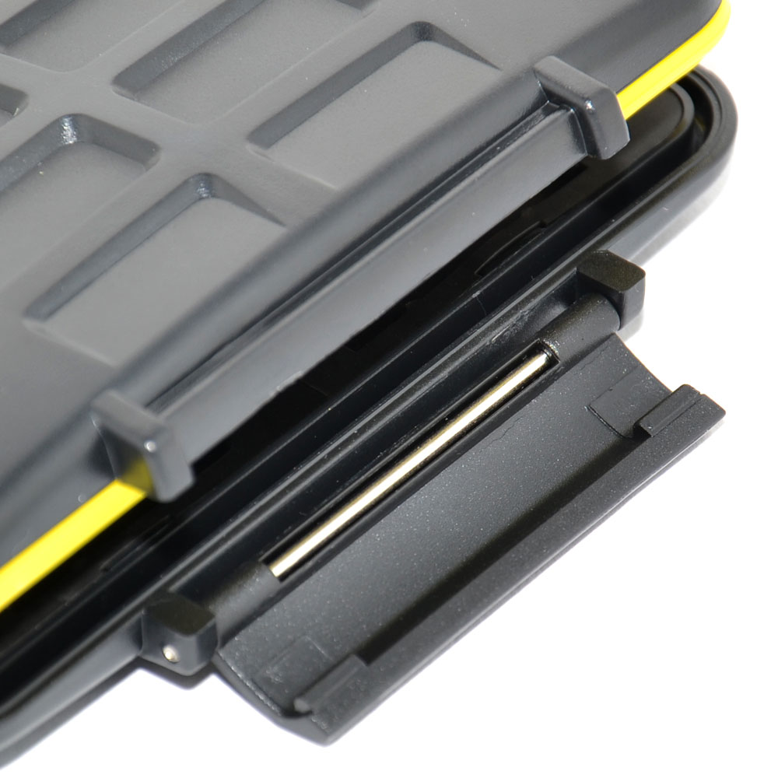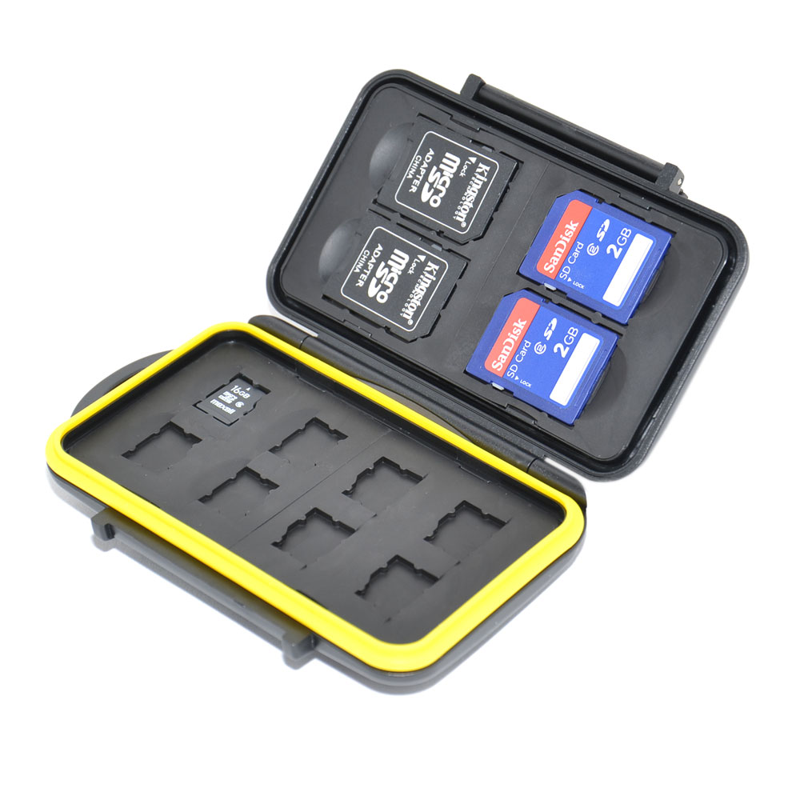
JJC MC-SDMSD12 Memory Card Case is a tough, water-resistant polycarbonate case made to carry and store memory cards. A molded protective rubber interior lining protects against harmful shocks, by securing each memory card within the MC case. Each slot is strictly tailored to fit the card perfectly and protects the cards from going around. The case adopts a compact design, one side allows you store 4 SD Cards while another side stores 8 micro SD cards. In this way, JJC MC-SDMSD12 enables you store 4 SD cards and 8 micro SD cards in all. The yellow water-resistant silicone seal keeps unwanted debris and water from entering the case. The ergonomic locking system keeps the cards securely in the case while allows you open it with your finger easily. In addition, the side of the case has an extra hole for easy carrying.

Specification:
Material: ABS + PC + TPU + Silicone
Stores: 4 SD cards and 8 micro SD cards
Color: Black
Size(L X W X D): 143mm X 80mm X 28mm
Weight: 154g

WWW.JJC.CC

