6-Piece Lens Set for Panasonic DMC-FZ70
Model: FZ70K(55MM)
Content: 1 Adapter + 2 filters + 1 Lens Hood +1 Lens Cap + 1 Cap Keeper
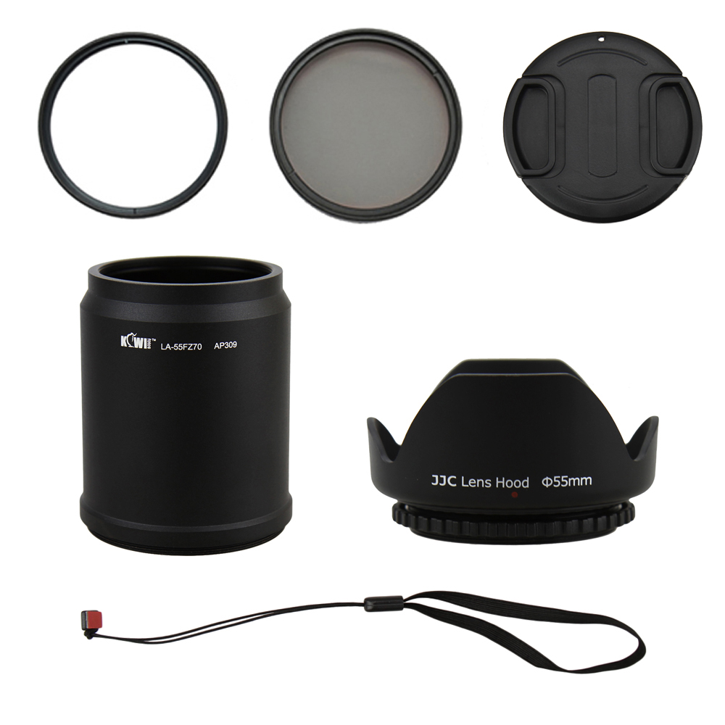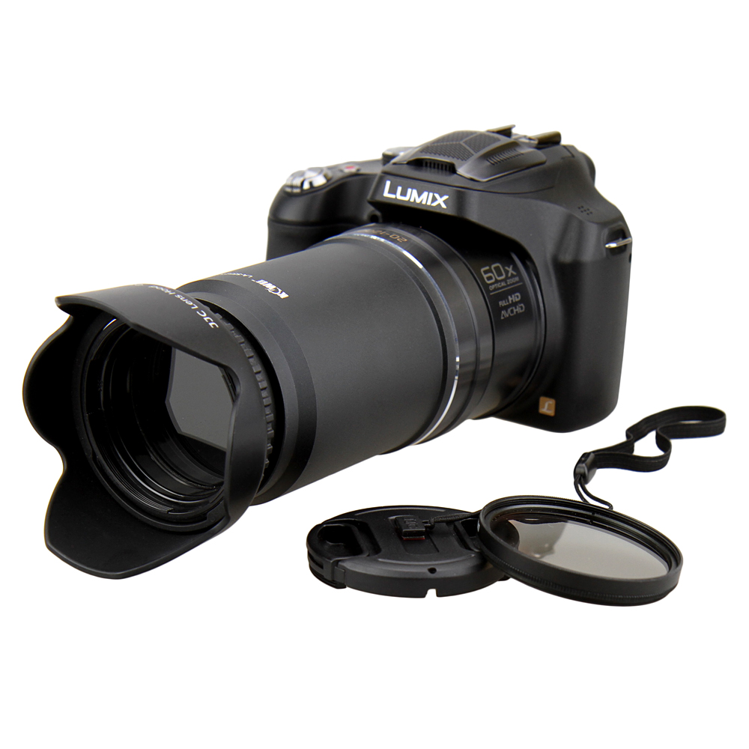

The KIWIFOTOS FZ70K (55mm) Lens Kit includes:

(1) 55mm Lens Adapter(Qty1)
Made of black anodized aluminum this adapter is a one-piece adapter works great with all zoom setting. It provides a 55mm filter mount for adding effects filters to the Panasonic DMC-FZ70 Digital Camera, improving picture quality and protecting your camera lens. To attach to your camera easily by switching clockwise and to detach by turning anti-clockwise. Vignetting might cause at certain zoom.

(2) 55mm High Resolution Filters - UV (Qty1) & CPL (Qty1)
The UV filter protects your camera's lens from scratches, dust, dirt, moisture and fingerprints, while reducing unwanted ultra-violet light. Cameras are more sensitive to ultraviolet light than our eyes are. A blue haze may appear in pictures taken when there is excessive UV light. A UV filter can reduce atmospheric haze and is recommended for all outdoor shooting. The Circular Polarizing Filter (CPL) allow you to remove the unwanted reflections from the non-metallic object surface such as water, glass etc. CPL filter is able to increase the contrast and saturation of your pictures, especially for the sky, clouds, plants. CPL filter is also used to select which light rays ( reflected by any object surface and become polarization) can be entered to your lenses.

(3)55mm screw mount Petal Crown Flower Shape Lens Hood (Qty1)
A universal lens hood fits for any 55mm filter size lens. It is designed to prevent unwanted stray light from entering the lens by extending and shading the end of the lens.

(4)55mm Lens Cap (Qty1) with Cap Keeper (Qty1)
Professional design center pinch snap-on lens cap with keeper not only protects your lens from dust and scratches but also protects you from losing the cap.

WWW.KIWIFOTOS.COM

