6-Piece Lens Set - P600K
1 Adapter + 2 Filters + 1 Lens Hood +1 Lens Cap + 1 Cap Keeper
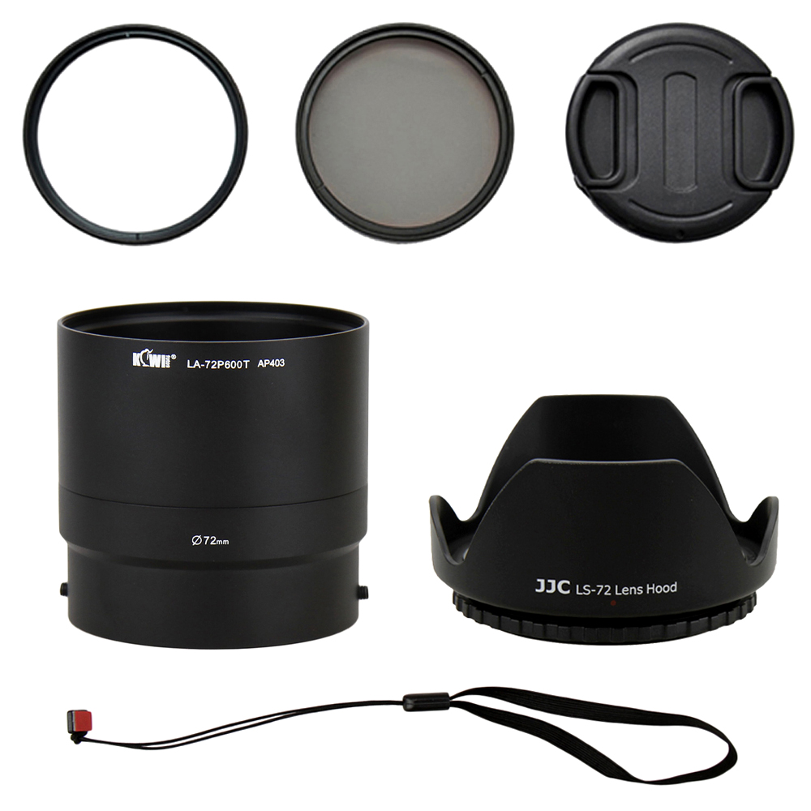
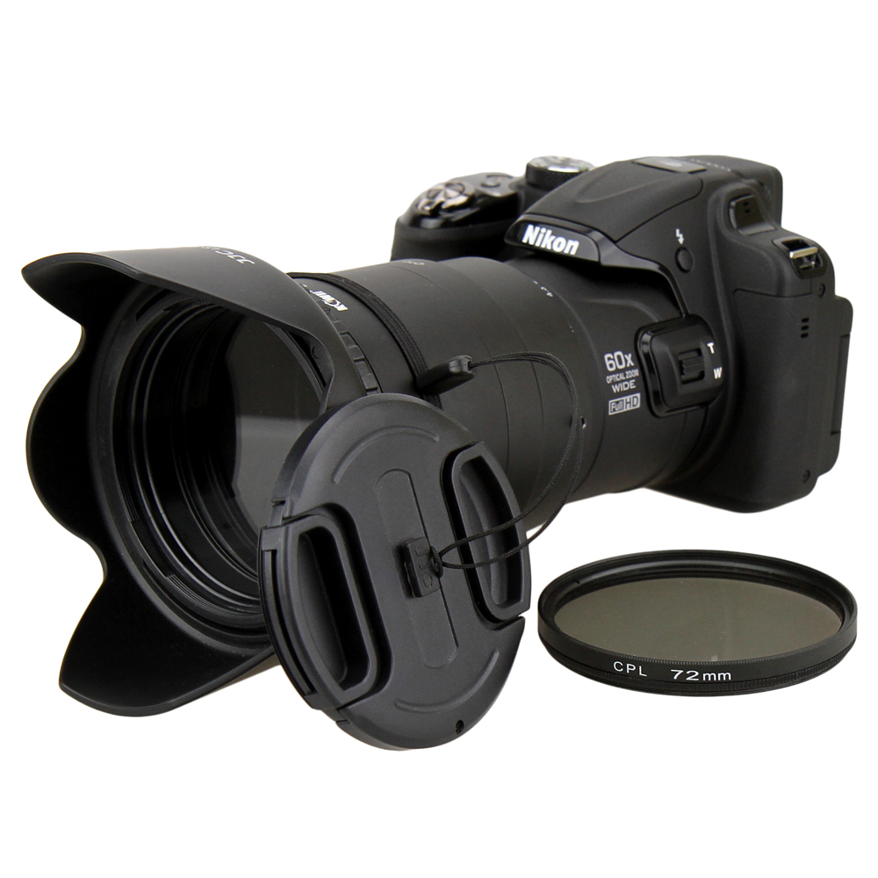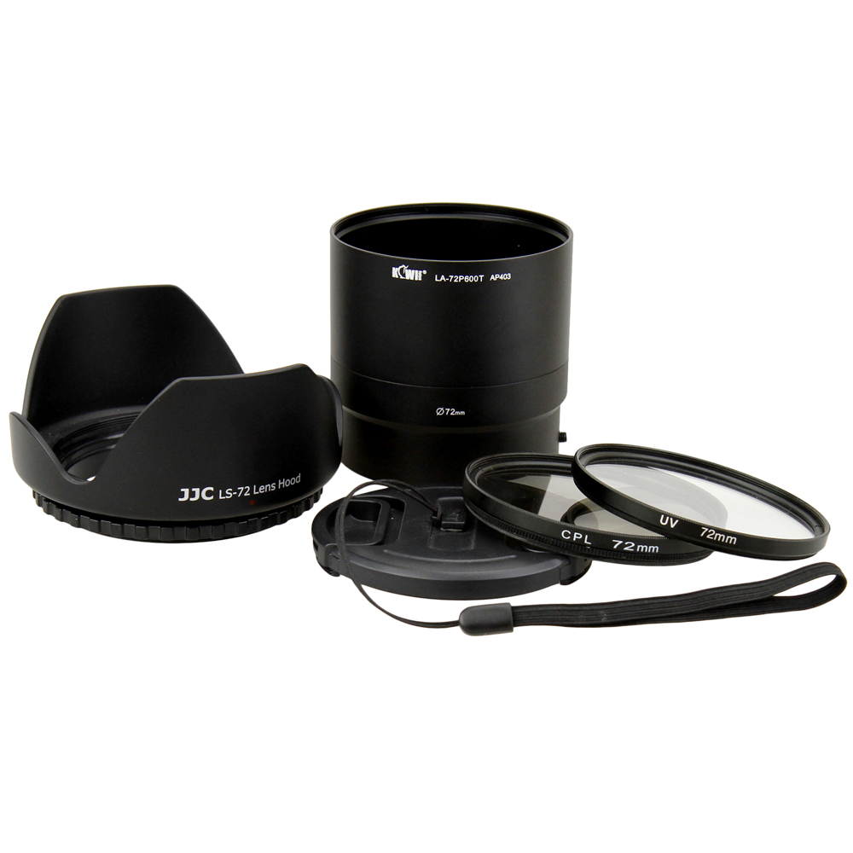

The KIWIFOTOS P600K Lens Kit includes:

(1) 72mm Lens Adapter (Qty1)
Made of black anodized aluminum the KIWIFOTOS LA-72P600T lens adapter provides a 72mm filter mount for adding effects filters and lens accessories(as tele/close-up/wide-angle lenses) to the Nikon COOLPIX P600 Digital Camera, improving picture quality and protecting your camera lens. With the back component of the adapter users can add a 72mm filter to improve picture quality at the widest zoom and it will not cause vignetting. In this case lens full zoom function is not applicable. For use with teleconverter and macro/close up lenses in full zoom screw both parts together and add a 72mm filter, it may cause vignetting, however. The special design of a smooth inner ring of the lens adapter helps protect your expensive camera from scratching during installation.

(2) 72mm High Resolution Filters - UV (Qty1) & CPL (Qty1)
The UV filter protects your camera's lens from scratches, dust, dirt, moisture and fingerprints, while reducing unwanted ultra-violet light. Cameras are more sensitive to ultraviolet light than our eyes are. A blue haze may appear in pictures taken when there is excessive UV light. A UV filter can reduce atmospheric haze and is recommended for all outdoor shooting. The Circular Polarizing Filter (CPL) allow you to remove the unwanted reflections from the non-metallic object surface such as water, glass etc. CPL filter is able to increase the contrast and saturation of your pictures, especially for the sky, clouds, plants. CPL filter is also used to select which light rays ( reflected by any object surface and become polarization) can be entered to your lenses.

(3)72mm Lens Hood (screw mount) Petal Crown Flower Shape(Qty1)
A universal lens hood fits for any 72mm filter size lens. It is designed to prevent unwanted stray light from entering the lens by extending and shading the end of the lens.

(4)72mm Lens Cap (Qty1) with Cap Keeper (Qty1)
Professional design center pinch snap-on lens cap with keeper not only protects your lens from dust and scratches but also protects you from losing the cap.

WWW.KIWIFOTOS.COM

