4-Piece Lens Set for Fujifilm FinePix S8600
Model: KWF-S8600

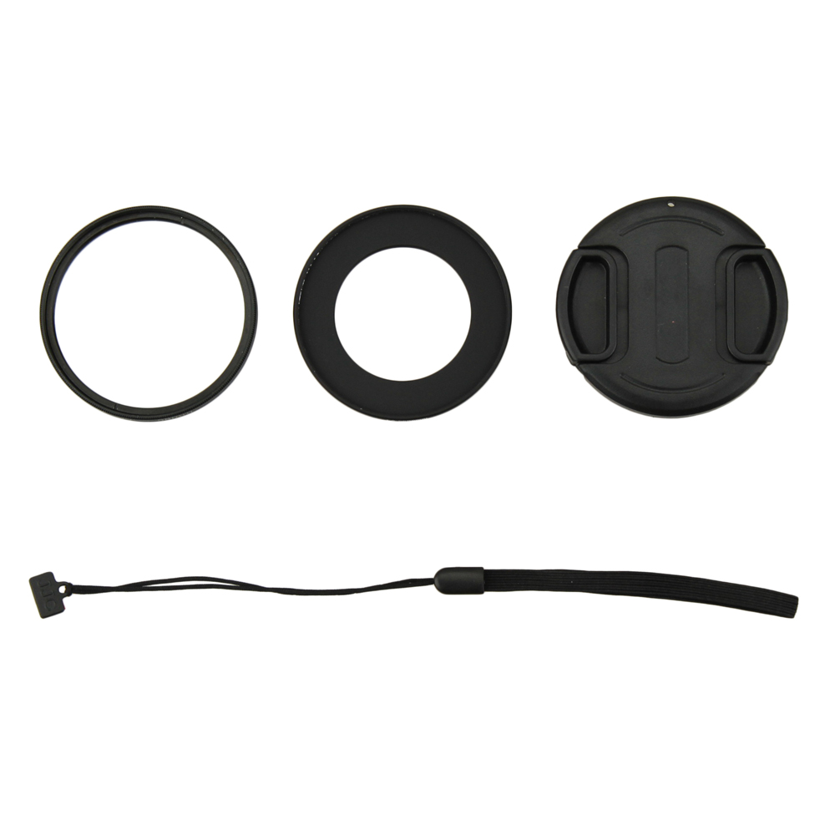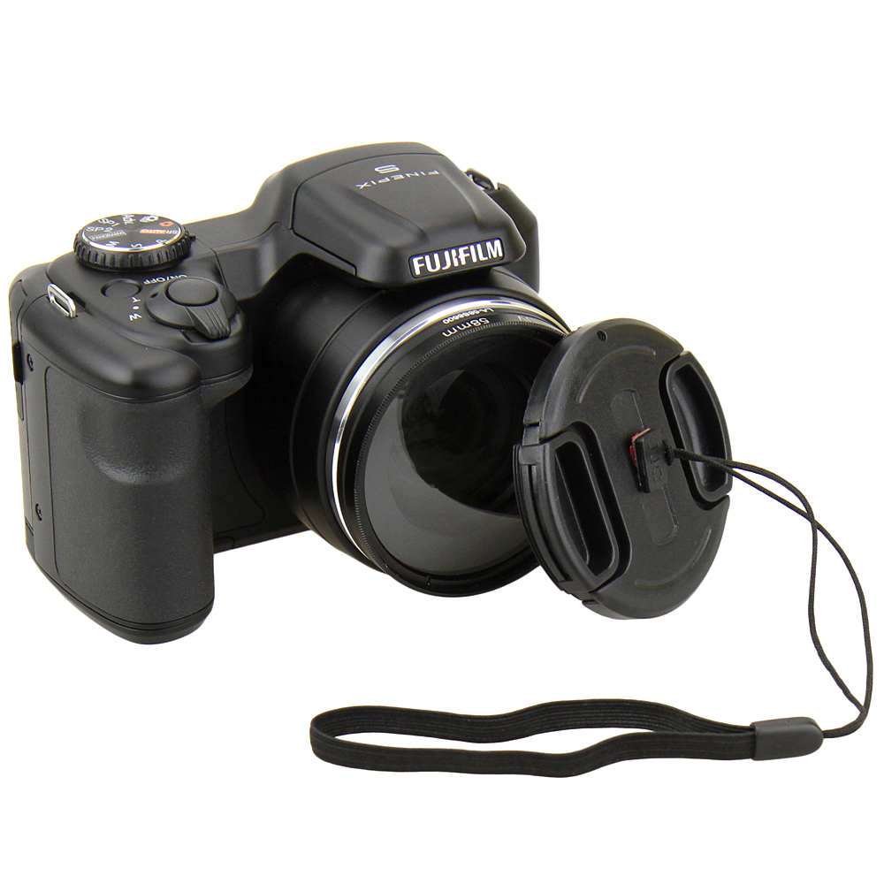
The KIWIFOTOS KWF-S8600 Lens set includes:

- 58mm Lens Adapter Ring (Qty1)
Made of black anodized aluminum the KIWIFOTOS LA-58S8600 lens adapter ring is designed for Fujifilm FinePix S8600 camera lens to accept any 58mm threaded filter, step-up ring or macro lens. Both screw-in thread designs make it easy to use. Vignetting might cause at zoom 200mm 1.4X.

(2) 58mm High Resolution Filter - UV (Qty1)
The UV filter protects your camera's lens from scratches, dust, dirt, moisture and fingerprints, while reducing unwanted ultra-violet light. Cameras are more sensitive to ultraviolet light than our eyes are. A blue haze may appear in pictures taken when there is excessive UV light. A UV filter can reduce atmospheric haze and is recommended for all outdoor shooting.

(3) 58mm Lens Cap (Qty1) with Cap Keeper (Qty1)
Professional design center pinch snap-on lens cap with keeper not only protects your lens from dust and scratches but also protects you from losing the cap.

WWW.KIWIFOTOS.COM

