6-Piece Lens Set - S1K
1 Adapter + 2 filters + 1 Lens Hood +1 Lens Cap + 1 Cap Keeper

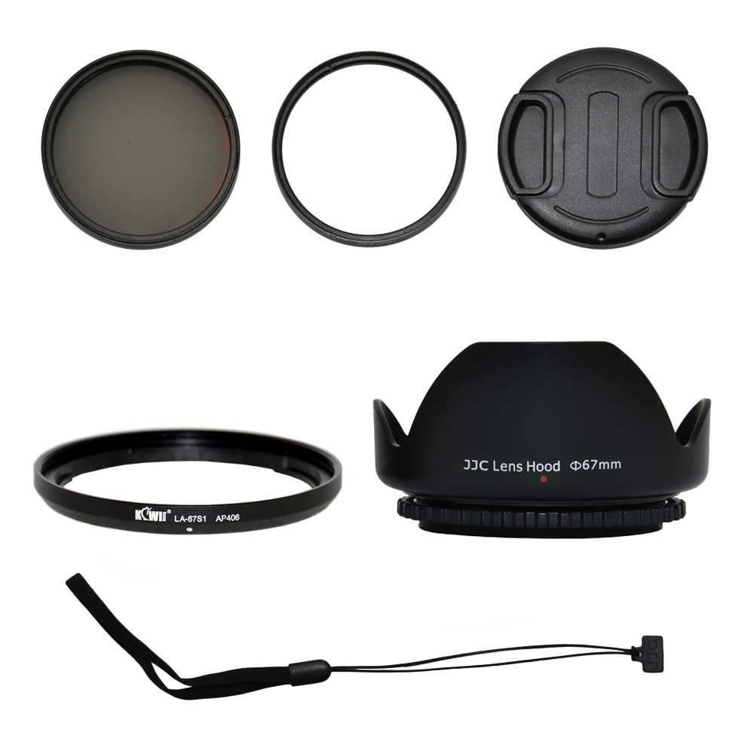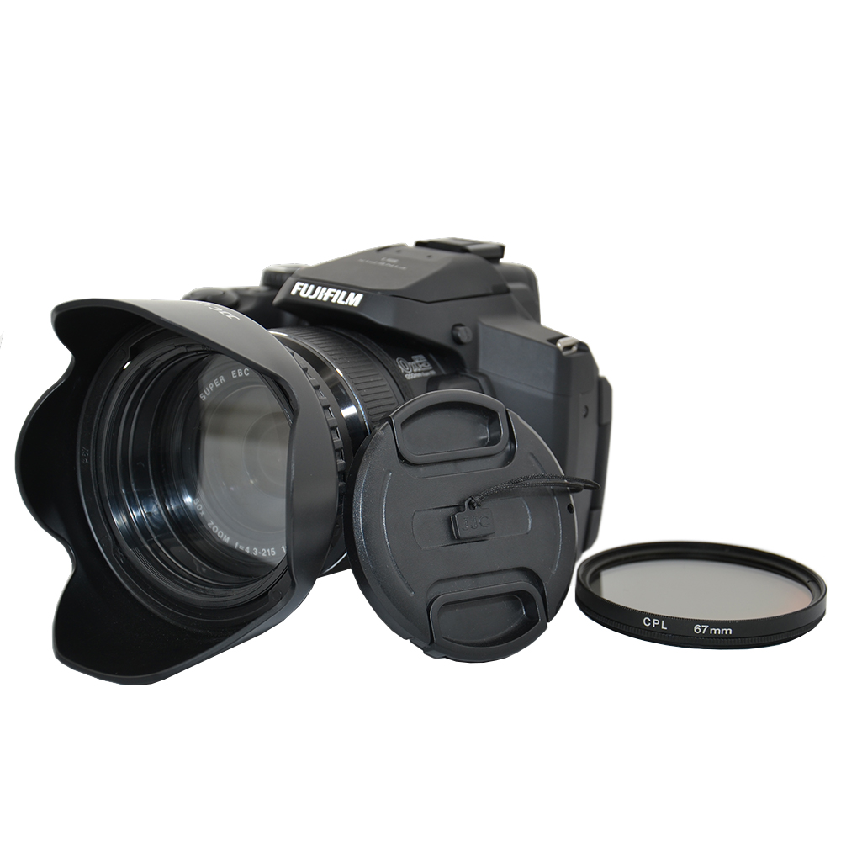

The KIWIFOTOS S1K Lens Kit includes:

(1) 67mm Lens Adapter Ring (Qty1)
Made of black anodized aluminum the KIWIFOTOS LA-67S1 lens adapter assembly bayonets onto the lens for quick changes, providing a 67MM filter thread for adding effect filters and optional lens accessories onto Fujifilm FinePix S1 camera. The adapter is retained by a low tension locking system, so very little torque is applied to the lens barrel when attaching and detaching it.

(2) 67mm High Resolution Filters - UV (Qty1) & CPL (Qty1)
The UV filter protects your camera's lens from scratches, dust, dirt, moisture and fingerprints, while reducing unwanted ultra-violet light. Cameras are more sensitive to ultraviolet light than our eyes are. A blue haze may appear in pictures taken when there is excessive UV light. A UV filter can reduce atmospheric haze and is recommended for all outdoor shooting. The Circular Polarizing Filter (CPL) allow you to remove the unwanted reflections from the non-metallic object surface such as water, glass etc. CPL filter is able to increase the contrast and saturation of your pictures, especially for the sky, clouds, plants. CPL filter is also used to select which light rays ( reflected by any object surface and become polarization) can be entered to your lenses.

(3)67mm Lens Hood (screw mount) Pentel Crown Flower Shape(Qty1)
The JJC lens hood fits for any 67mm filter size lens. It is designed to prevent unwanted stray light from entering the lens by extending and shading the end of the lens.

(4)67mm Lens Cap (Qty1) with Cap Keeper (Qty1)
Professional design center pinch snap-on lens cap with keeper not only protects your lens from dust and scratches but also protects you from losing the cap.

WWW.KIWIFOTOS.COM

