Lens Adapter
Model: LA-72P600T

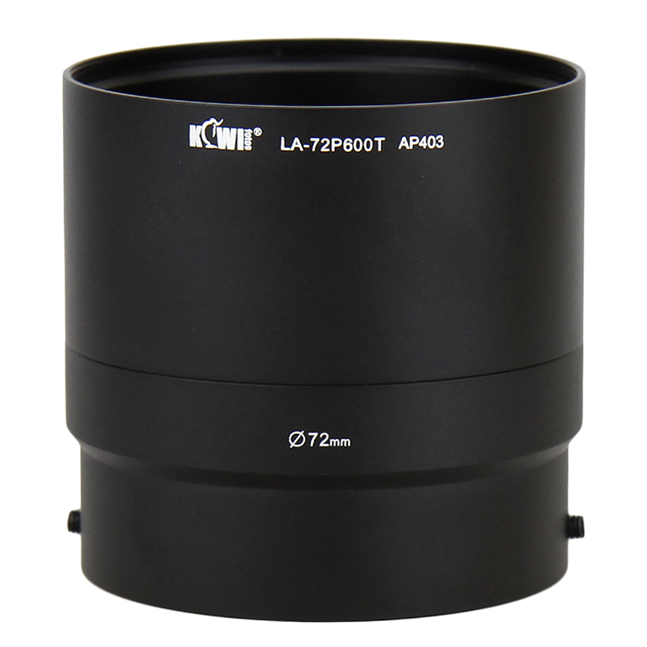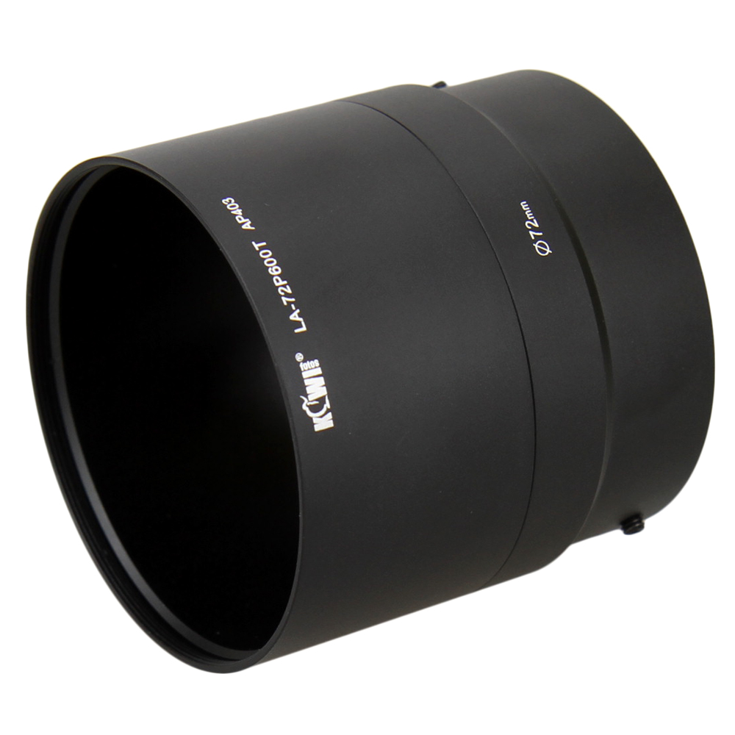
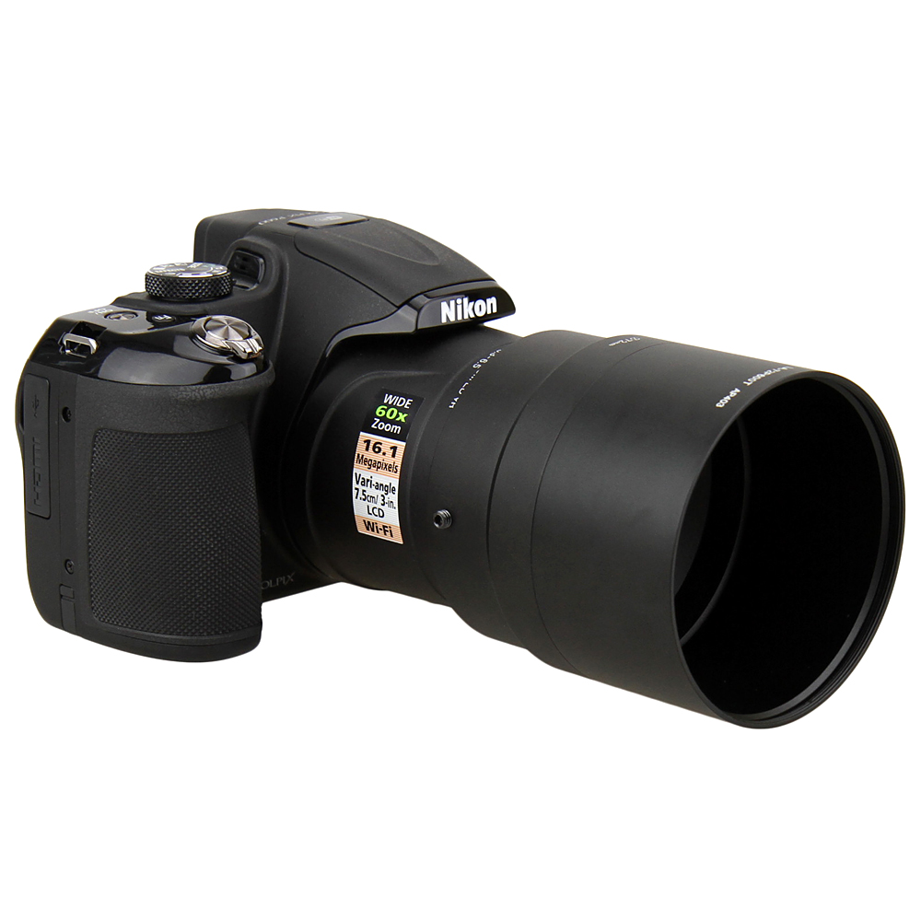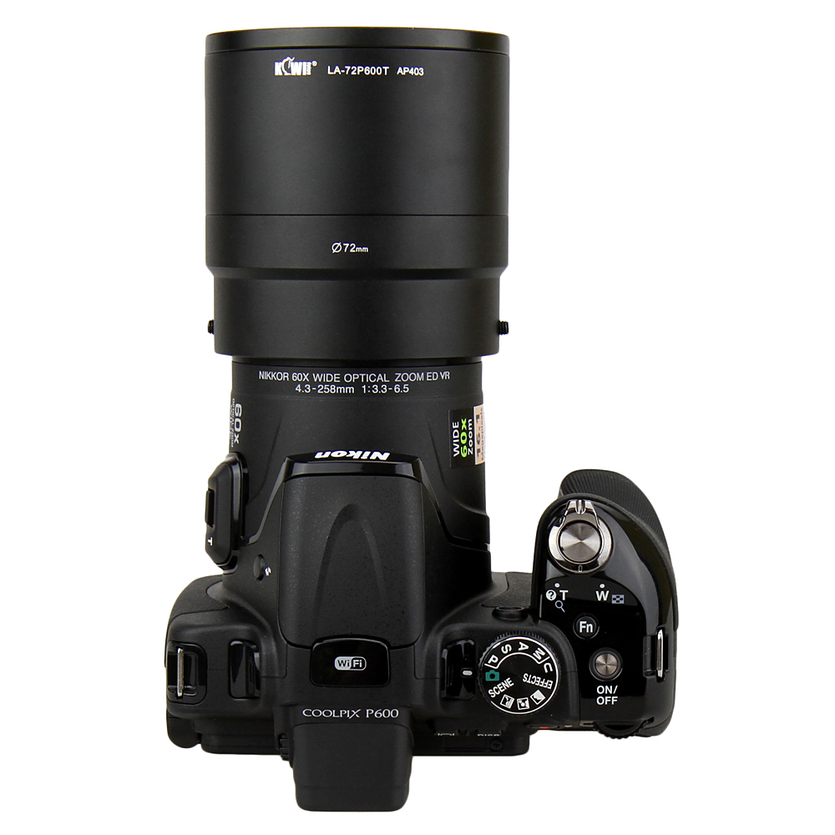

Made of black anodized aluminum the KIWIFOTOS LA-72P600T lens adapter provides a 72mm filter mount for adding effects filters and lens accessories(as tele/close-up/wide-angle lenses)to the Nikon COOLPIX P600 Digital Camera, improving picture quality and protecting your camera lens. With the back component of the adapter users can add a 72mm filter to improve picture quality at the widest zoom and it will not cause vignetting. In this case lens full zoom function is not applicable. For use with teleconverter and macro/close up lenses in full zoom screw both parts together and add a 72mm filter, it may cause vignetting, however. The special design of a smooth inner ring of the lens adapter helps protect your expensive camera from scratching during installation.

WWW.KIWIFOTOS.COM

