Lens Adapter
Model: LA-62P520
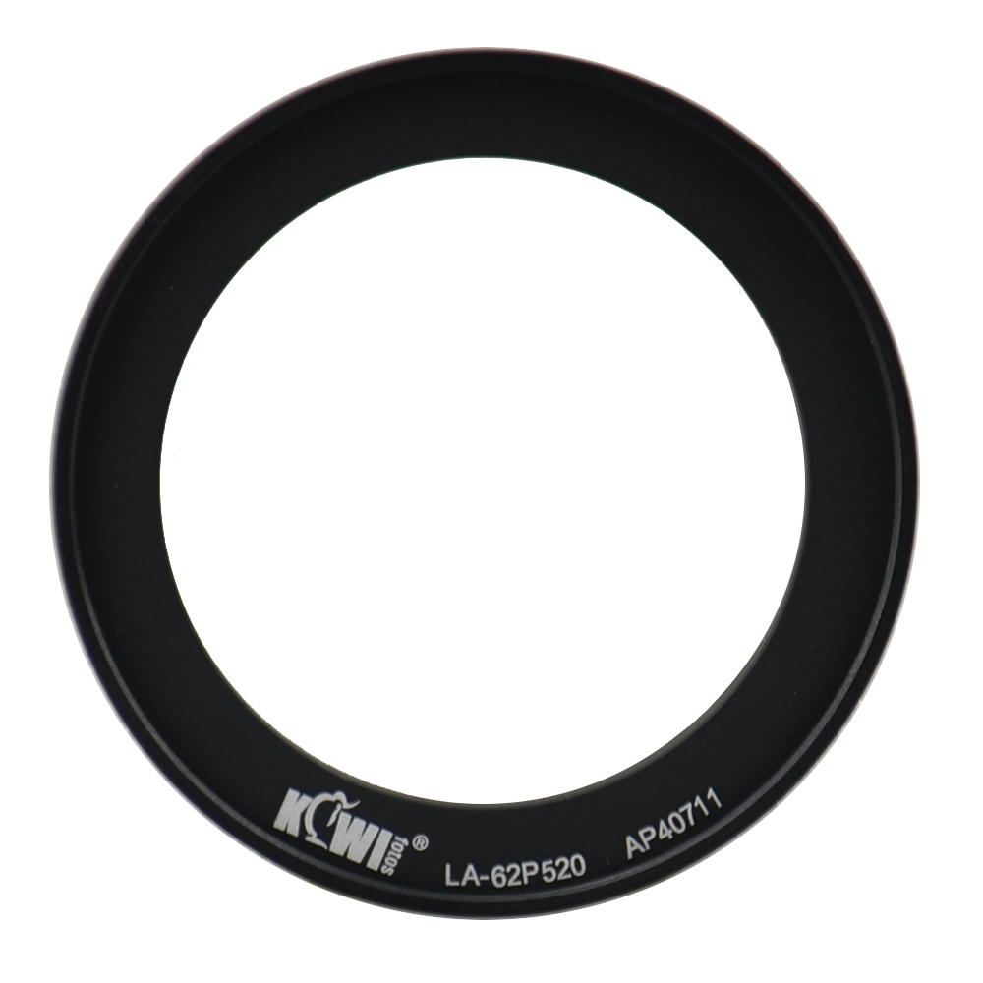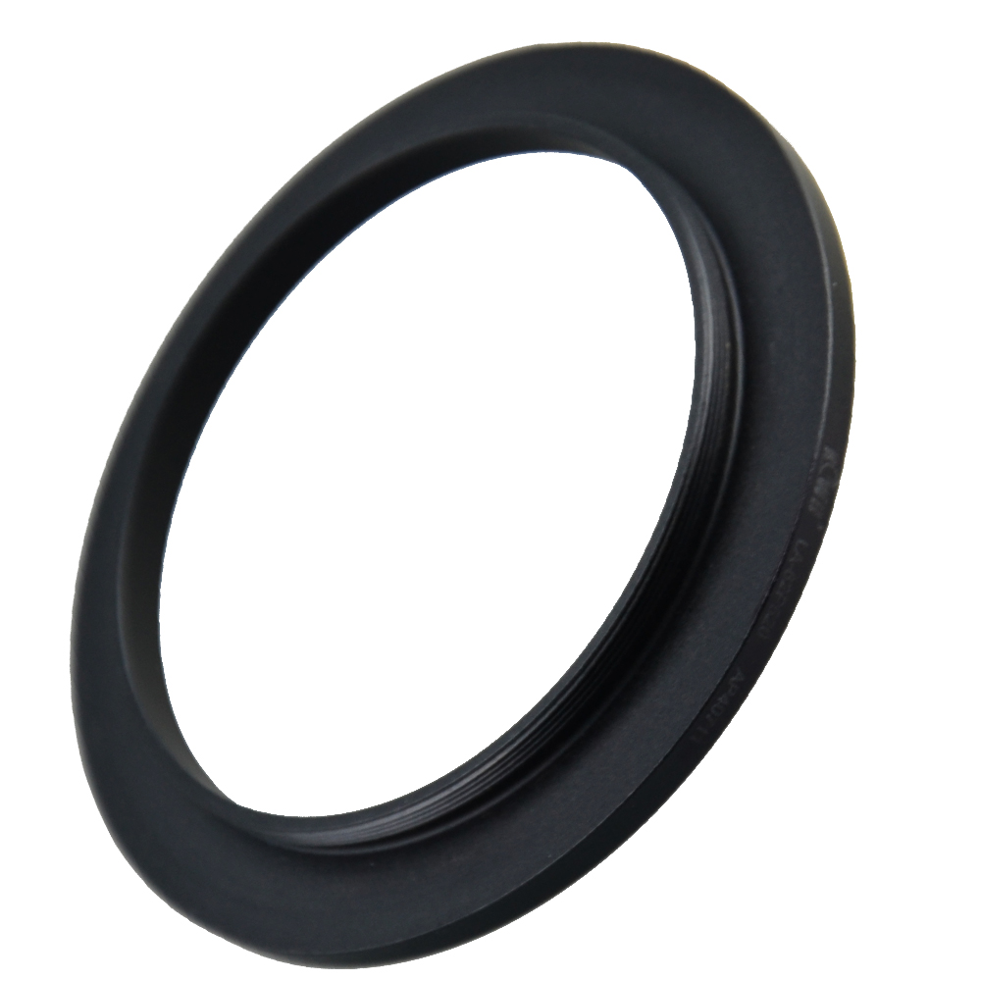
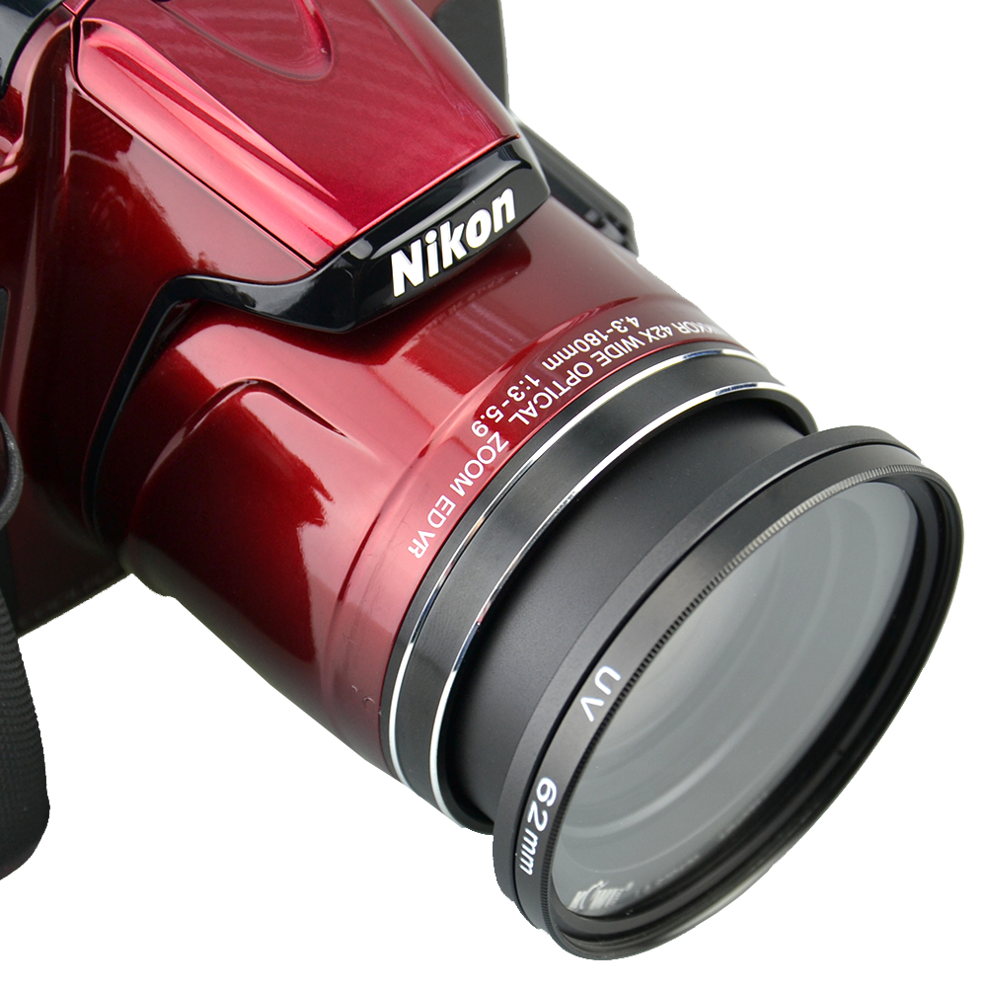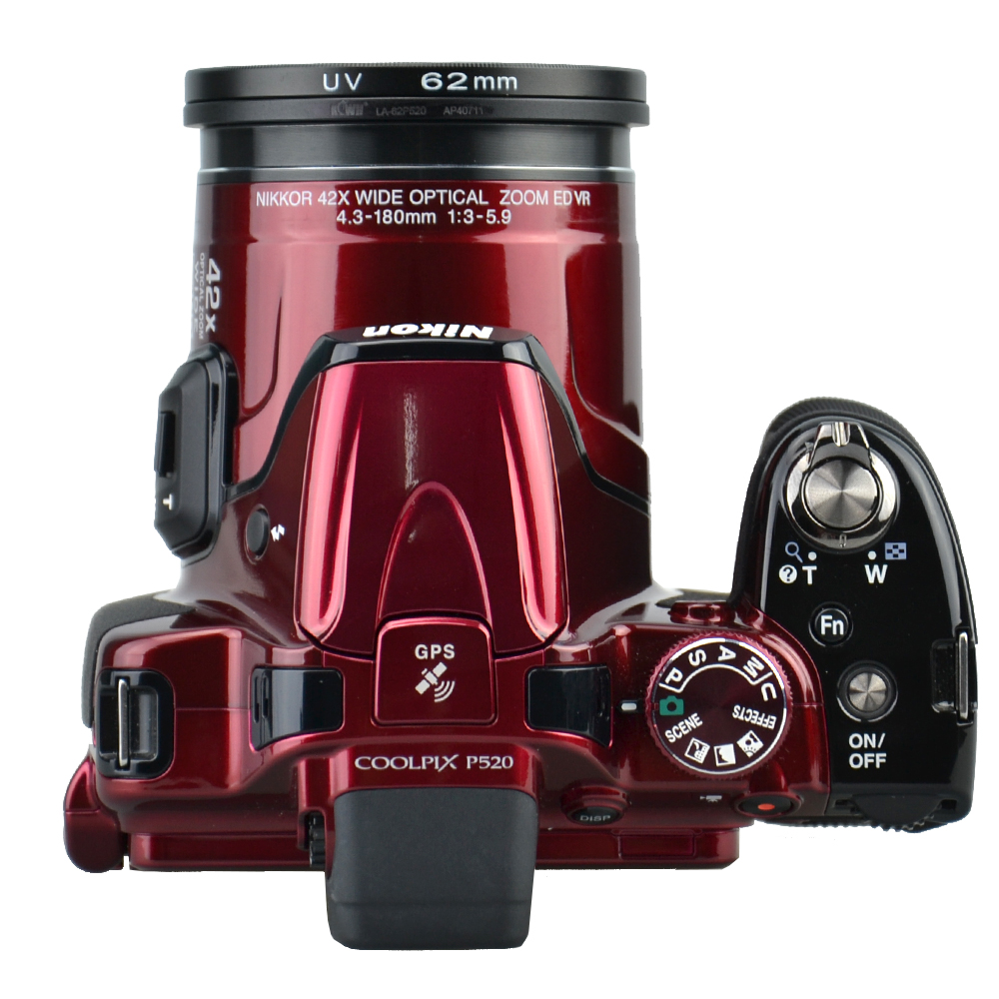

Made of black anodized aluminum the KIWIFOTOS LA-62P520 lens adapter ring is designed for Nikon Coolpix P510 / P520 / P530 camera lens to accept any 62mm threaded filter or 62mm lens cap. It adopts a screw design for adding desirable filter to achieve improved image quality or various effects of pictures. With a filter attached, your lens also get the added benefit of some extra protection from accidental impact or scratch. The adapter allows you to mount a standard 62mm lens cap.
Product highlights
- Provides a 62mm thread for a filter
- Provides some extra protection to your lens
- Allows you get pictures of better quality
How to use
- Align the thread on the LA-62P520 with the thread of your lens, then rotate the adapter with lens clockwise until it comes to a completed stop.
- Screw a 62mm filter (UV,CPL,ND filter etc.) to the front thread of the adapter ring.

WWW.KIWIFOTOS.COM

