JJC RN-S1 Filter Adapter
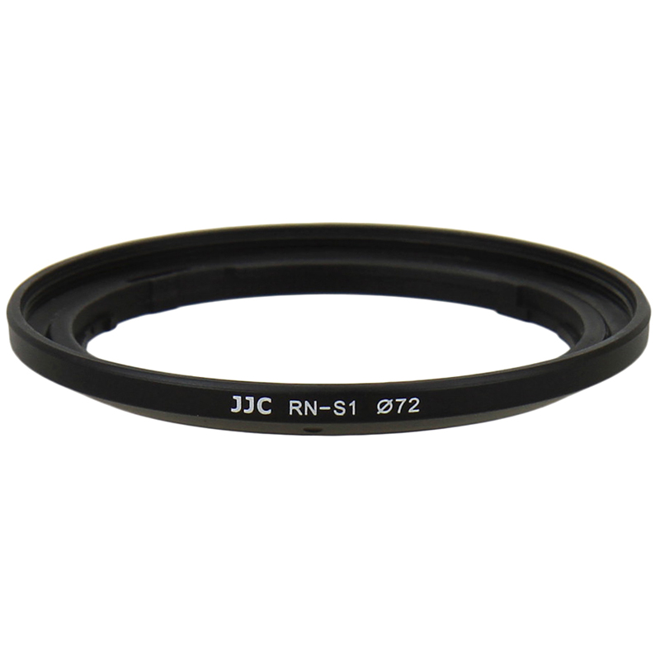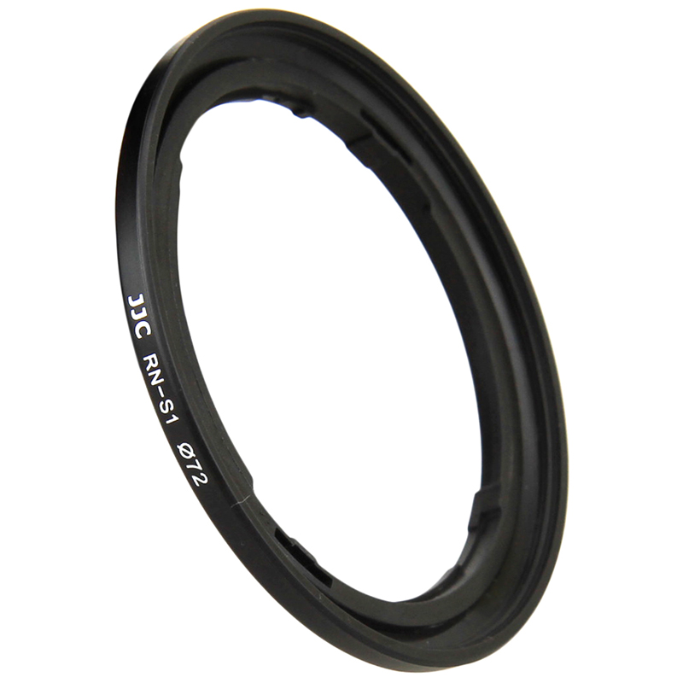
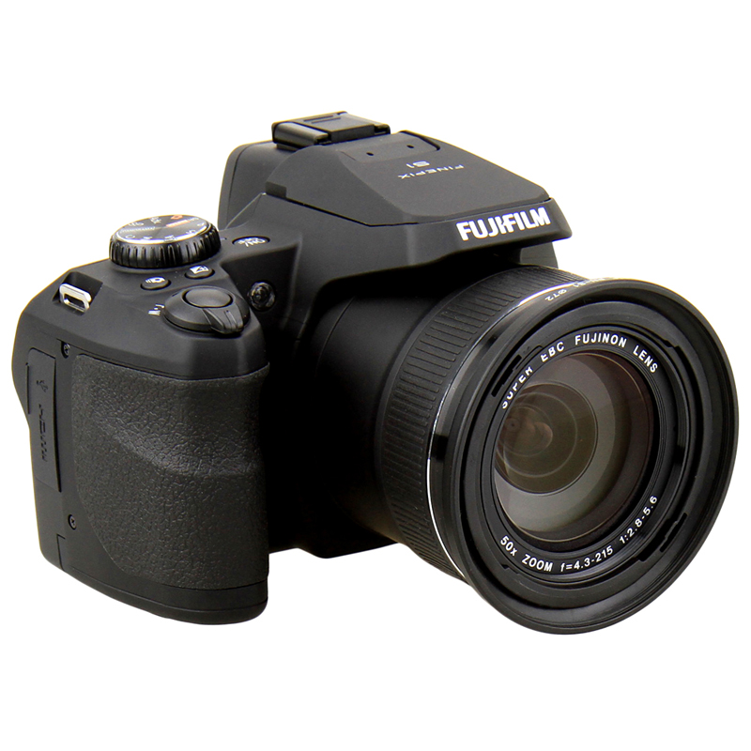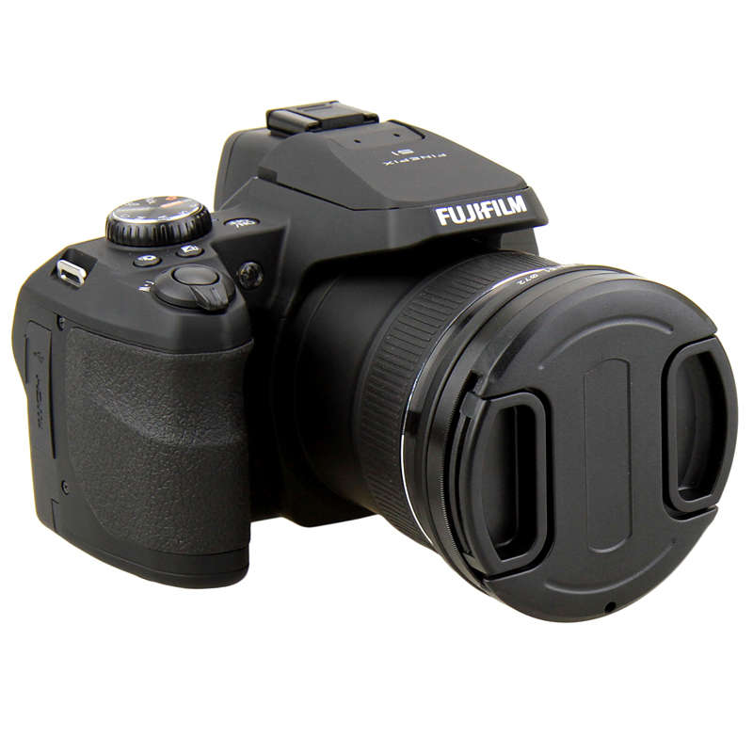

JJC RN-S1 filter adapter provides a thread for FUJIFILM FinePix S1 camera to mount a 72mm filter. It easily screws onto FUJIFILM FinePix S1, then you can add on a 72mm filter to achieve pictures of better quality. With a filter attached, your lens also get the added benefit of some extra protection from accidental impact or scratch. When the shooting finished, you can even mount a 72mm lens cap to the filter.

Product highlights
- Provides a 72mm thread for a filter
- Provides some extra protection to your lens
- Allows you get pictures of better quality

Compatible with
FUJIFILM FinePix S1 Camera

WWW.JJC.CC

