JJC S-IOS Wired Remote Switch
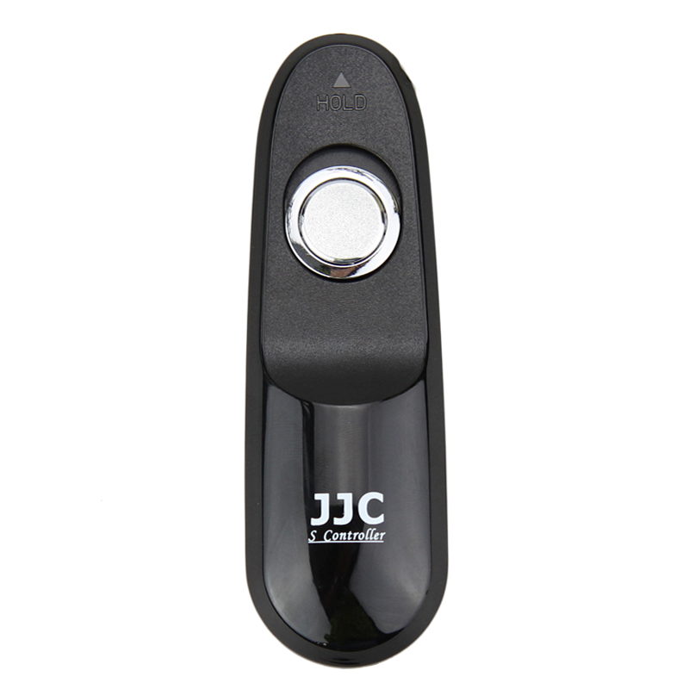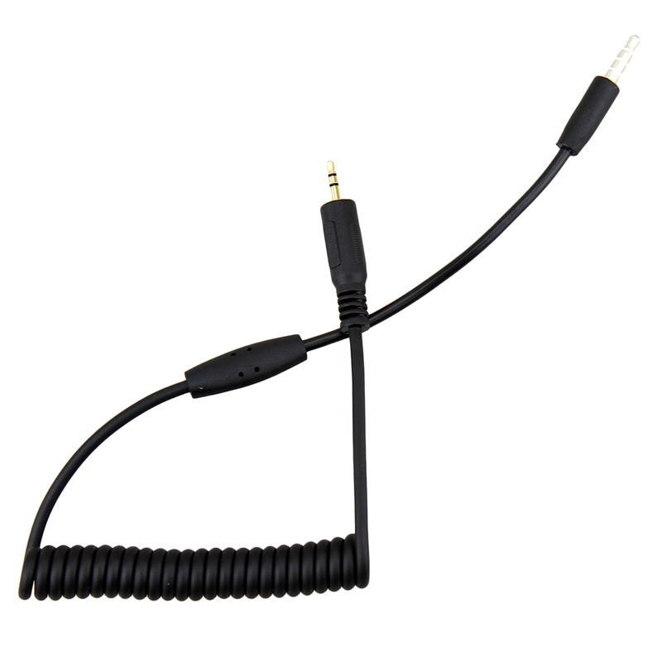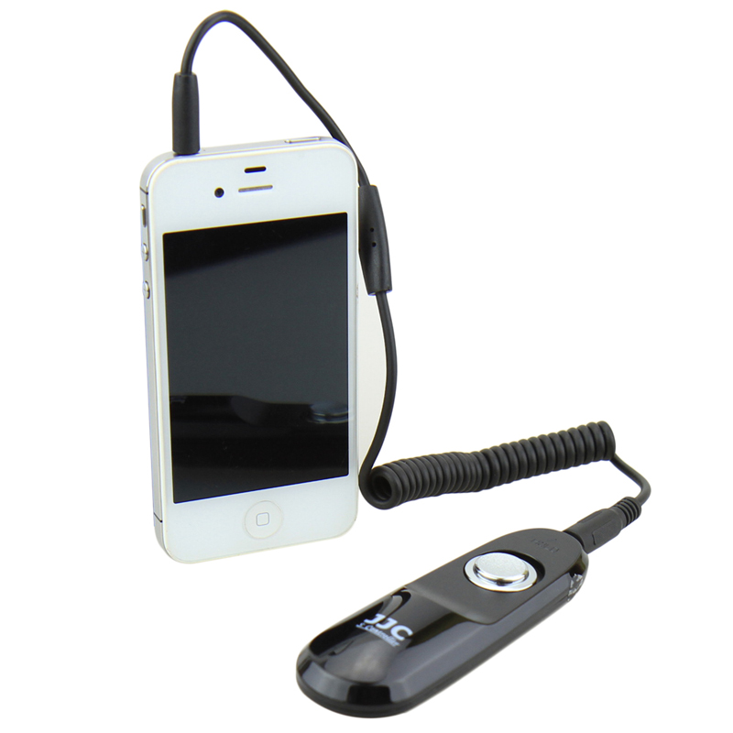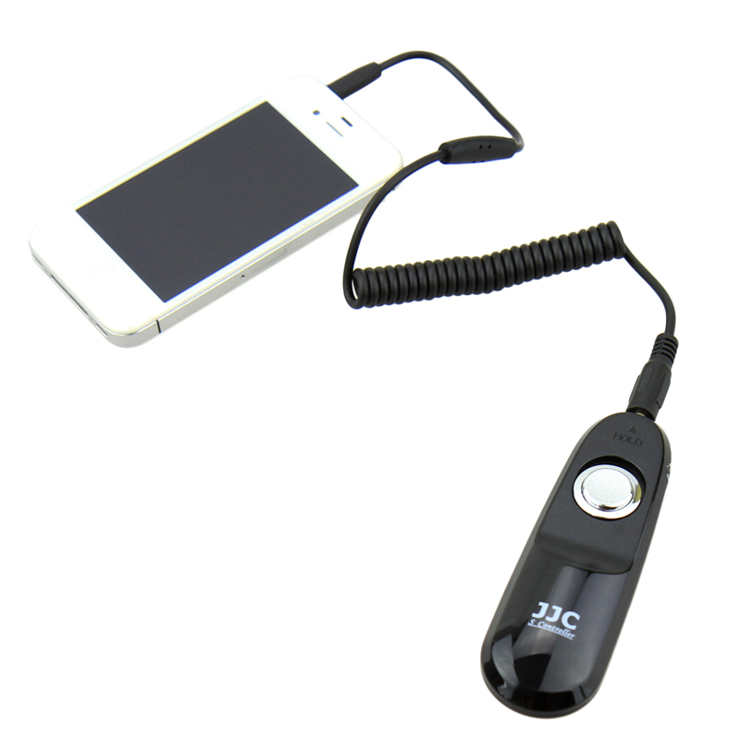
JJC S-IOS remote switch is a compact wired remote switch designed for IPHONE/IPAD/ITOUCH. It allows you control your IPHONE/IPAD/ITOUCH remotely without shaking your device, now you will be easier to catch perfect photos. The remote switch is useful for taking self-portraits. In addition, this remote switch also allows you control the video recording remotely. With this remote switch, you will get another choice to take photos and videos with your IPHONE/IPAD/ITOUCH.

Product Highlights
- No battery required-Powered by device
- Control shutter triggering
- Allow you start and stop the video
- Ideal choice for self-portraits
- Prevent shaking for catching perfect photos

Compatible with
IPHONE/IPAD/ITOUCH (Requires IOS 5.0 or above)

WWW.JJC.CC

