JJC Flash Diffuser FC-SB400
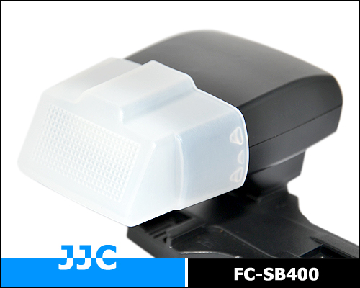
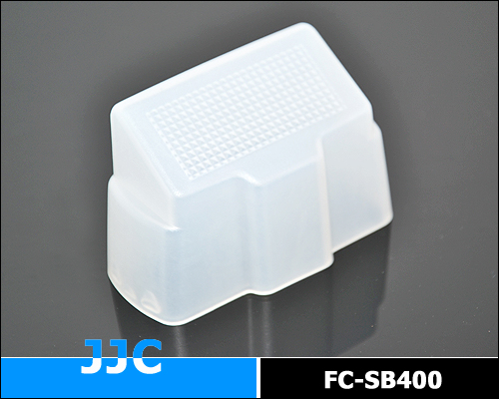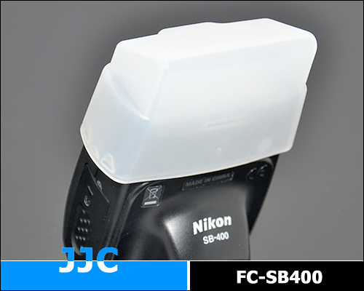
JJC FC-SB400 flash dome diffuser is a latest product specifically designed for NIKON SB-400 SPEEDLITE. Comparing with our previous FC-26P diffuser, this diffuser can soften the light more significantly while attached on the SB-400 more tightly. It can soften the light output of a flash. In effect, the light will not come from one concentrated source (like a spotlight), but spread out, bounce from reflective ceilings and walls instead, thus reducing harsh shadows that are often the result when using direct illumination. Flash diffuser is particularly useful for portrait photographers, since harsh light and hard shadows are usually not considered flattering in a portrait.

Highlights:
- Custom tailored for NIKON SB-400
- Soften the light more significantly
- Attached on the SB-400 more tightly

Compatible With:
NIKON SPEEDLITE SB-400
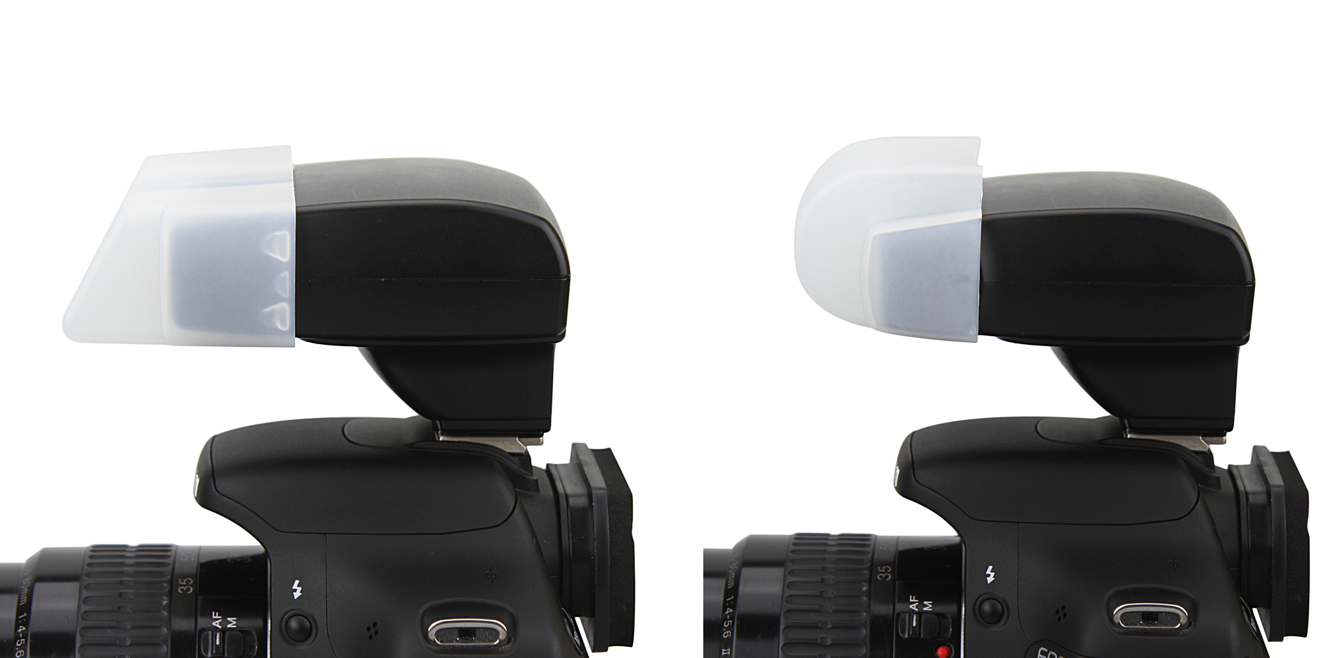
FC-SB400
FC-26P
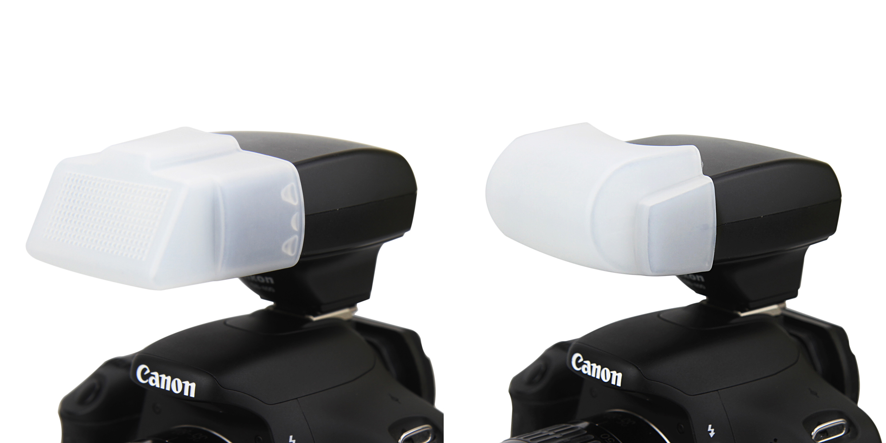
FC-SB400
FC-26P

WWW.JJC.CC

