JJC Flash Diffuser FC-26S
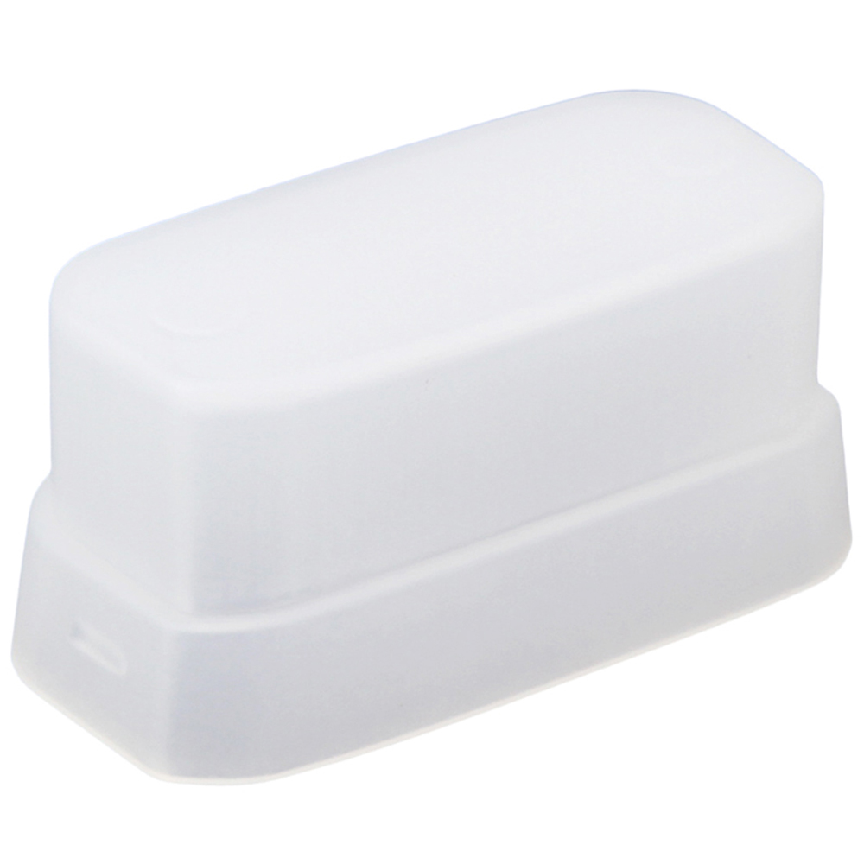
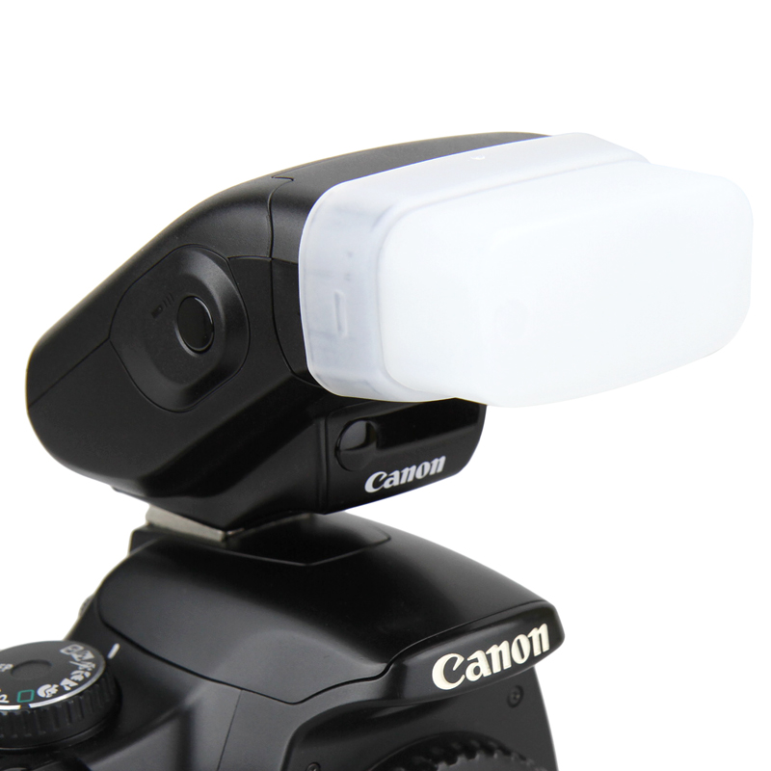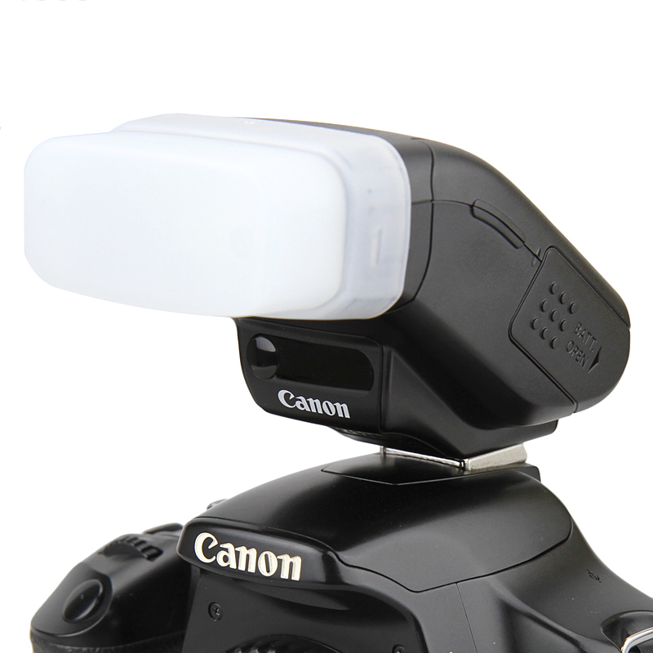
JJC FC-26S flash diffuser is specifically designed for Canon SPEEDLITE 270EX and Canon SPEEDLITE 270EX II. It can spread the light from the flash of a camera. In effect, the light will not come from one concentrated source (like a spotlight), but spread out, bounce from reflective ceilings and walls instead, thus getting rid of harsh light and hard shadows. This is particularly useful for portrait photographers, since harsh light and hard shadows are usually not considered flattering in a portrait. JJC FC-26S flash diffuser adopts a compact design, it looks like a soapbox and can be easily mount to Canon SPEEDLITE 270EX and 270EX II.

